Wk 7:
Editor’s note: As Creation magazine has been continuously published since 1978, we are publishing some of the articles from the archives for historical interest, such as this. For teaching and sharing purposes, readers are advised to supplement these historic articles with more up-to-date ones suggested in the Related Articles below.

Flood!
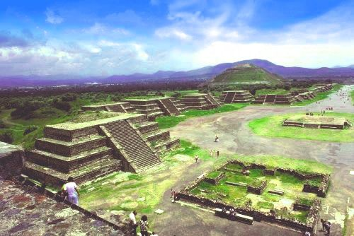
by Rebecca Conolly and Russell Grigg
“When mankind were overwhelmed with the deluge, none were preserved but a man named Coxcox … and a woman called Xochiquetzal, who saved themselves in a little bark, and having afterwards got to land upon a mountain called by them Colhuacan, had there a great many children; … these children were all born dumb, until a dove from a lofty tree imparted to them languages, but differing so much that they could not understand one another.”¹
A garbled version of the biblical accounts of Noah and Babel? Perhaps. This story comes from the Aztecs of Mexico—one of many such tales, from geographically remote and widely divergent cultures, that speak of a cataclysmic flood.

A wealth of deluge legends

Mesopotamia
Tablets excavated from Iraq recount the myths of ancient Mesopotamia. They speak of a vanished culture in Sumer and of a king called Gilgamesh. He was renowned for his great wisdom and knowledge. Gilgamesh related the story of a worldwide flood. This was told to him by Utnapishtim, a king of a pre-flood civilisation and a survivor of the catastrophe.
The story relates that Ea, lord of the waters and man’s guardian, warned Utnapishtim of the deluge by which the gods planned to exterminate mankind. Ea told Utnapishtim to “tear down your house and build a boat” and to “take up into the boat the seed of all living creatures. … [E]ach side of the deck measured one hundred and twenty cubits, making a square”. There were seven decks in all. The flood itself was frightening and full of fury. Utnapishtim recounted that ‘the god of the storm turned daylight to darkness, when he smashed the land like a cup’. Once the tempest had subsided, Utnapishtim ‘looked at the face of the world and there was silence, all mankind was returned to clay. The surface of the sea stretched flat as a rooftop … on every side was the waste of water’. Utnapishtim loosed a dove who returned finding no resting place, and then a swallow with the same result. Finally, a loosed raven did not return. The boat came to ground on a mountaintop and Utnapishtim offered a sacrifice.²

North American Indians
The North American Indians have several flood stories. One from the Choctaw tribe tells how, long ago, men became so corrupt that the Great Spirit destroyed them in a flood. Only one man was saved—a prophet whose warnings the people disregarded, and whom the Great Spirit then directed to build a raft from sassafras logs. After many weeks, a small bird guided the prophet to an island where the Great Spirit changed the bird into a beautiful woman who became the wife of the prophet. Their children then repopulated the world.³

Australian Aboriginal flood stories
Likewise, there are several Australian Aboriginal flood stories. One tells how, long ago, there was a flood that covered the mountains so that many of the Nurrumbunguttias, or spirit men and women, were drowned. Others, including Pund-jil, were caught up by a whirlwind into the sky. When the waters receded, and the mountains appeared again, and the sea went back into its own place, the son and daughter of Pund-jil ‘went back to earth and became the first of the true men and women who live in the world today’.⁴

Ancient Chinese
Early Jesuit scholars were the first Europeans to gain access to the Chinese ‘book of all knowledge’ from ancient times. This 4,320-volume collection told of the repercussions of mankind’s rebellion against the gods: “The Earth was shaken to its foundations. The sky sank lower towards the north. The sun, moon, and stars changed their motions. The Earth fell to pieces and the waters in its bosom rushed upwards with violence and overflowed the Earth.”⁵
Another story, in the folklore of the Bahnars, a primitive tribe of Cochin, China, tells of how the rivers swelled “till the waters reached the sky, and all living beings perished except two, a brother and a sister, who were saved in a huge chest. They took with them into the chest a pair of every sort of animal …”.⁶

Egypt
Flood stories from the continent of Africa are rare, but one from Egypt tells of an ancient creation god, Tem, who “was responsible for the primeval flood, which covered the entire earth and destroyed all of mankind except those in Tem’ boat”.⁷

Peru
The Incas of Peru also had a tradition of a deluge. “They said that the water rose above the highest mountains in the world, so that all people and all created things perished. No living thing escaped except a man and a woman, who floated in a box on the face of the waters and so were saved.”⁸

Scandinavia
The stories of the Teutonic tribes of Scandinavia are vivid and describe terrifying events. The imagery of these legends emphasizes the size of the cataclysm. One such tale portrays the chaos of the world when the mighty wolf Fenrir shook himself and “made the whole world tremble. The aged ash tree Yggdrasil [envisaged as the axis of the earth] was shaken from its roots to its topmost branches. Mountains crumbled or split from top to bottom … ”. Men “were driven from their hearths and the human race was swept from the surface of the earth. The earth itself was beginning to lose its shape. Already the stars were coming adrift from the sky and falling into the gaping void. … Flames spurted from fissures in the rocks; everywhere there was the hissing of steam. All living things, all plant life, were blotted out. … And now all the rivers, all the seas rose and overflowed. From every side waves lashed against waves. They swelled and boiled and slowly covered all things. The earth sank beneath the sea …”. Then slowly “the earth emerged from the waves. Mountains rose anew … . Men also reappeared. … Enclosed in the wood itself of the ash tree Yggdrasil … the ancestors of a future race of men had escaped death.”⁹
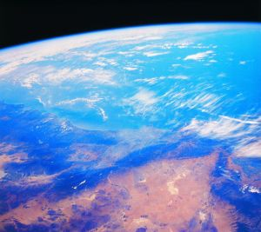

Uncanny coherence to Noah’s account
There are at least 500 legends of a worldwide deluge. Many of these show remarkable similarities, with many aspects similar to the details about Noah’s Flood in the Bible (see aside below).
We are left with a few options. Perhaps all the peoples of these remote civilisations had different flood experiences that, by chance, had all these features in common, on which they based their stories. However, the more reasonable alternative is that these legends all find their root in the same one global Flood experience that Genesis records.
So why do sceptics reject the story today? The Bible says that people willingly close their minds about the Flood: “For this is hidden from them by their willing it, that the heavens were of old, and the earth out of the water, and through water, being held together by the word of God, through which the world that then was, being flooded by water, perished” (2 Peter 3:5-6).
The Bible also proclaims that this world is being reserved for another cataclysm: “But the day of the Lord will come as a thief in the night, in which the heavens will pass away with a rushing noise, and the elements will melt with fervent heat. And the earth and the works in it will be burned up” (2 Peter 3:10).
All too often we rest in the surety of yet another benevolent sunrise. We rely too smugly upon the delicate balance that makes life on our planet possible. The ancient prophecies and legends, corruptions though they are of the original true account, help to remind us of our vulnerability before God. We should humbly bow the knee and get in step with His purposes. They are the only purposes that really count.

Australian Aboriginals relate legend of world-destroying flood
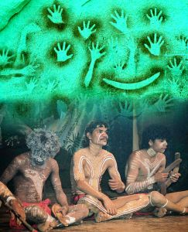
One of the more striking Flood accounts, summarized here, was discovered by anthropologists among a remote Aboriginal tribe in Western Australia, before any contact with missionaries.
“It came about that the earliest-time children tormented and ill-treated the Winking Owl, Dumbi. Ngadja, the Supreme One, was inwardly grieved and felt deep sorrow for him. He instructed Gajara, ‘If you want to live, take your wife, your sons and your sons’ wives and get a double raft. Because of the Dumbi affair, I intend to drown everyone. I am about to send rain and a sea flood,’ he told them. ‘Put on the raft long-lasting foods that may be stored, foods such as gumi, banimba, and ngalindaja, all these ground foods.’
“So Gajara stored all these foods. He also gathered birds of the air such as the cuckoo, the mistletoe-eater, the rainbow bird, the helmeted friar bird and finches; these he took on the raft, and also a female kangaroo. Gajara gathered his sons as the crew, and his own wife and his sons’ wives together.
“Then Ngadja sent the rainclouds down, shutting the clouds in upon them. The sea-flood came in from the north-north-east and the people were closed in by the salt-water flood and the tidal waters of the sea. Ngadja whirled the flood waters and the earth opened, drowning and flattening them all. He finished them at Dumbey. Meanwhile, the flood carried all those who were on the raft with Gajara along on the current far away to Dulugun.
“At last, the floodwaters brought Gajara back in this direction. He sent some birds out from the raft, first the cuckoo. The cuckoo found the land and did not return to him. Gradually the waters were going down. Later on, the other birds returned to Gajara and he sent them out again the following day. The land was already drying the waters up and the living creatures found a home and food. They killed a kangaroo after landing, and Gajara’s wife, Galgalbiri, put it in the earth oven and cooked it with other foods. The smoke rose slowly until it reached through into the sky. Ngadja, the Supreme Being, could smell the steam and smoke rising from the female kangaroo as it was cooking and he was pleased.
“Ngadja, the Supreme Being, put the rainbow in the sky to keep the rain-clouds back. The rainbow protects us so that the rainfall does not rise too high. Our people understand the significance of it. When we see the rainbow we say, ‘There will not be any abnormally heavy rain.’.”¹⁰

Flood stories around the globe
Mountain High Maps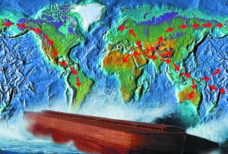
Funk and Wagnall’s 1950 Dictionary of Folklore, Mythology and Legend stated under the heading ‘Deluge or Flood’: “A world cataclysm during which the earth was inundated or submerged by water: a concept found in almost every mythology in the world. The exceptions are Egypt and Japan …” [But see Egyptian myth mentioned above (Ref. 7).] It goes on to describe the ‘bare bones of the usual deluge story’ as follows: “The gods (or a god) decide to send a deluge on the world, usually as punishment for some act, broken tabu, the killing of an animal, etc. (in a Tsimshian myth the deluge comes because the people have mistreated a trout), but sometimes for no reason. Certain human beings are warned, or it comes without warning. If warned, the people construct some kind of vessel (raft, ark, ship, Big Canoe, or the like), or find other means of escape (climbing a mountain or tree, growing tree, floating island, calabash or coconut shell, a turtle’s back, crab’s cave, etc.). Sometimes they also save certain things essential to a way of life, such as food, rarely domestic animals. The deluge comes (rain, huge wave, a container broken or opened, a monster’s belly punctured, etc.). Bird or rodent scouts are often sent out, but this is not universal. When the deluge is over the survivors find themselves on a mountain or an island; sometimes they offer a sacrifice (not universal), and then repeople the earth, recreate animals, etc., by some miraculous means.”¹¹
If there were no near-universal distribution of world-destroying flood legends, sceptics would no doubt attack the Bible’ credibility on this basis, questioning how the memory of such an awesome account could be lost in so many cultures.
The dictionary quoted from here seemed to feel the need to reassure its readers with, “The fact [of a world Flood] itself finds no place in the geological history of the earth … .” But arguing against a global Flood on the basis of the earth’s ‘geological history’ of ‘long ages’ is only sound if that long-age history is a correct reading of the rocks, and the long-age reading is only true if there was no global Flood. This is known as the logical fallacy of ‘begging the question’—assuming that which you are trying to prove.¹² The cultural memories of a world-destroying Flood, obviously altered by centuries of telling and retelling, are powerful, worldwide evidence consistent with the veracity of Genesis. They are an exciting reminder of the way in which the true history of the Bible connects with the real world of today.
Editor’s note: As Creation magazine has been continuously published since 1978, we are publishing some of the articles from the archives for historical interest, such as this. For teaching and sharing purposes, readers are advised to supplement these historic articles with more up-to-date ones suggested in the Related Articles and Further Reading below.

Coal: memorial to the Flood
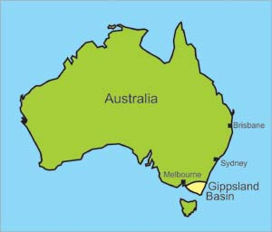The Gippsland Basin, deposited at the edge of the Australian continent.
by Tas Walker
South-East Australia’s Latrobe Valley has some extremely thick deposits of brown coal which are mined to fuel several huge power stations. One bucket-wheel excavator removes the relatively thin overburden and exposes the coal seam. Another excavator digs the coal and drops it onto a moving conveyor belt for the power-station boilers.¹
The machines are immense, towering over the people who work on them. Indeed, a person could easily disappear inside one of the many buckets. Each excavator can dig up to 60,000 tonnes of coal each day.¹ Yet the coal seams are so thick that they dwarf these massive excavators, which must traverse the seam several times before the coal is completely removed.

Huge coal basin
The coal seams occur within thick layers of clay, sand and basaltic lava, which together form a 700-metre (2,300-foot) sequence of rocks, known as the Latrobe Valley Coal Measures.² These lie in a large, deep depression, called a ‘basin’, shaped like a triangle 300 km (190 miles) long and 300 km (190 miles) wide (see diagram below). Most of the basin lies under the ocean off the southern coast of Australia. Offshore the coal measures are estimated to be almost 5 km (3 miles) thick.
Latrobe Valley coal consists of a mass of very fine plant debris containing partly-decomposed plant remains.¹ It is clear that a great quantity of plant material accumulated in the past to produce such huge deposits of coal.
Yallourn Energy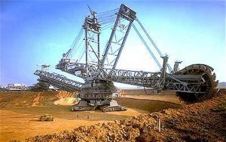Massive machines such as these excavate the coal and associated overburden. | photo by Ken Ham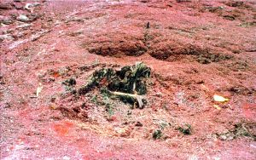This huge tree trunk, broken and dumped by watery cataclysm, is now coalified.

How did the coal get there?
How would such a great amount of vegetation collect together in one place? No-one alive today has ever observed such a process. All scientists can do is to invent plausible explanations based on what they think may have happened.
It is consistent with the devastation of Noah’ Flood, which would have uprooted the entire pre-Flood biosphere and buried it with huge quantities of sand and mud.
For those who believe the Bible, the presence of such great quantities of buried vegetation is easily explained. It is consistent with the devastation of Noah’s Flood, which would have uprooted the entire pre-Flood biosphere and buried it with huge quantities of sand and mud.
However, geologists who do not believe the Bible base their explanations on a different philosophy. They are committed, from the outset, to explaining the evidence using what we see happening today. There has only ever been one global Flood, and according to the Bible it occurred some 4,300 years ago. Since it can’t be observed today, these geologists will not accept that it happened in the past. Thus, they try to explain everything by slow and gradual processes over millions of years.
For these brown coal deposits, they say that the vegetation accumulated as peat in a swamp during ideal climatic and geologic conditions.¹ They say the swamps formed on floodplains near the coast,² which were slowly sinking and eventually inundated by the ocean.³
Photo by Ken Ham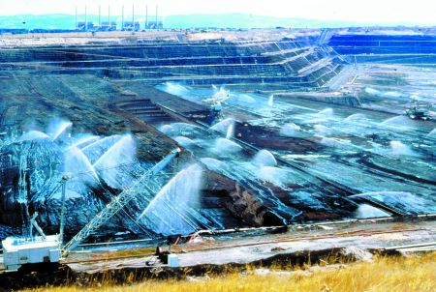Water sprayed on the huge exposed seam settles dust and keeps the air clean, and prevents a fire hazard with explosive coal dust.

Evidence against the swamp theory
But the evidence indicates that these brown coal deposits did not accumulate in a peat bog or a swamp.
First, there is no sign of soil under the coal, as there would be if the vegetation grew and accumulated in a swamp. Instead, the coal rests on a thick layer of clay and there is a ‘knife edge’ contact between the clay and the coal.² This kaolin clay is so pure that it could be used for high-class pottery. Furthermore, there are no roots penetrating the clay.
Then there are a number of distinct ash layers that run horizontally through the coal. If the vegetation had grown in a swamp, these distinct ash layers would not be there. After each volcanic eruption, the volcanic texture of the ash would have been obliterated when the swamp plants recolonized the ash, turning it into soil. Not only is there no soil, but the vegetation found in the coal is not the kind that grows in swamps today. Instead, it is mostly the kind that is found in mountain rainforests. The best match for the mix of vegetation in the coal occurs in the mountains of the western half of the island of New Guinea some 1,200–2,200 metres (4,000–7,000 feet) above sea level.⁴ Similar vegetation is also found in the mountains in Australia, Malaysia, New Caledonia and New Zealand. The kinds of plants that make up the coal did not grow in a swamp on a floodplain.
Large broken tree trunks are found randomly distributed through the coal in many different orientations. Even swamp advocates wonder how such large trees could have obtained an adequate root-hold in the ‘very soft, organic medium’, and how the roots could have breathed under water.⁵ These large trunks are not consistent with slow accumulation over thousands and thousands of years in a swamp, but indicate fierce and rapid transportation by water. See Sinking the swamp theory below.
Within the coal seams are pollen-rich layers up to half a metre (20 inches) thick. It makes sense that the pollen was washed there by water, because flowing water would sort vegetation into its different components. The idea that such huge pollen-rich layers could gradually accumulate in a coastal swamp over long periods of time does not make sense. There would have been some very bad seasons for hay fever!
When the brown coal burns, it leaves hardly any ash behind. The ash produced from most of these coals ranges from 1.5–5%,⁶ which is less than the 3–18% ash in typical peat.⁷ The low ash is consistent with the vegetation being transported and washed by water, not with lying in a swamp for tens of thousands of years.
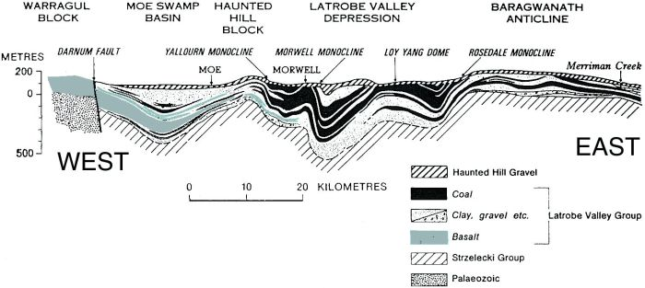Geological cross-section of the eastern Gippsland Basin, including the Latrobe Valley depression (after Hocking²). The tops of the coal measure were eroded as they folded.

An unbelievable story
When the evidence points so convincingly to large-scale water transport, why would some geologists think that the coal formed in a swamp? Simply because we do not see water transporting and accumulating vegetation in these quantities anywhere on the Earth today. It would obviously take a lot of water, and everything would have to be quickly buried before the vegetation decomposed. The amount of water needed speaks of continental-scale catastrophe, and this goes against the geologists’ prior commitment to slow and gradual processes.
Photos by Tas Walker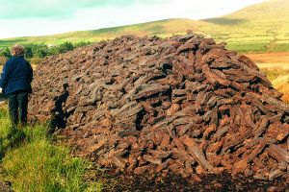Peat retrieved from the marshy ground is a good source of fuel for fires. Such relatively thin, local bogs do not match the massive Latrobe Valley brown coal deposits.
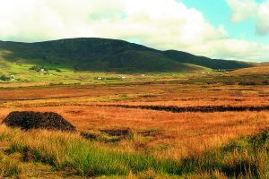A peat bog in the Ring of Kerry, south-western Ireland.
So, philosophically, the uniformitarian geologist rejects catastrophic water transport and thereby creates problems for himself. Obviously an environment conducive to prolific growth is needed, but growth alone is not enough. He must find a mechanism to conserve the vegetation for tens (or even hundreds) of thousands of years, until enough material has accumulated. Oxygen must be kept out to prevent decomposition, hence the need for stagnant water—a swamp. These are the only places where vegetation accumulates today. In all other environments vegetation decomposes as quickly as it is produced.
But how would such great thicknesses of peat accumulate in a swamp? Very precise geologic conditions would have been called for; namely that the swamp must have subsided slowly, at exactly the same rate as the vegetation was accumulating. If it had sunk too fast, the water would have drowned the plants, and growth would have been stopped. If it had sunk too slowly, the organic debris would have emerged above the water and decomposed. And these precise geologic conditions would be needed for tens, or hundreds of thousands of years!⁸ Geologically, the idea that thick seams of brown coal accumulated in a swamp is ridiculous in the extreme.
Not only does the swamp model have problems explaining the seam thickness, but it is also difficult to envisage how vegetation could have accumulated over such a large geographical area. As well as covering a huge area of land, the Latrobe Valley Coal Measures extend hundreds of kilometres under the ocean to the continental shelf. Indeed, the crude oil under Bass Strait was derived from these coal deposits after they were heated in the Earth. Even today the oil continues to form under the sea.⁹ How could the precise environmental and geological conditions have been preserved over such a large area for such a long time? Understandably we do not see peat swamps covering such extensive geographic areas today. Rather, peat only accumulates in relatively small, isolated swamps.¹⁰
Contrary to what some people believe, it does not take millions of years to produce coal and oil.
Contrary to what some people believe, it does not take millions of years to produce coal and oil. Once we understand the conditions needed (see aside below), it is clear that the 4,300 years since Noah’s Flood is ample time for all the buried vegetation to have transformed into brown coal.

Deposited during Noah’s Flood
The location of the Gippsland Basin suggests that it was filled with sediment early in the second part of Noah’s Flood (the Recessive stage: see aside on Biblical geology, below).¹¹ As they flowed off the land, the receding floodwaters would have deposited sediment around the edges of the continent. After the coal measures were deposited, they were compressed horizontally by earth movements to form broad gentle folds. Interestingly, while the sediments were folding, the tops of the folds were sliced off, consistent with erosion by broad sheets of receding floodwaters.
Continued erosion by fast-flowing water eroded the uplands to the north of the Gippsland Basin and covered the coal measures with sands and gravels. Finally, local erosion by the present rivers brought some of the thick coal seams close to the present land surface where they are now mined. After the land was dry, new plants sprouted from the scattered clumps of vegetation left on the surface by the receding floodwaters. Thus, the kinds of plants in Australia today are similar to the plants in the coal buried during the final stage of the Flood.
If ever there was a geological phenomenon that should remind us of Noah’s Flood, it is coal. Coal points to a global catastrophe, because huge quantities of vegetation have been uprooted, transported, and buried by water under great volumes of sediment all over the world. Coal is a stark memorial to the Flood of Noah, and bears witness to the reliability of the Bible.
Photo by Hazlewood Power, Latrobe Valley, Victoria.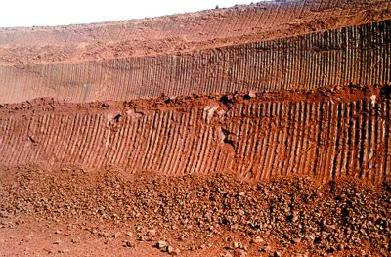Distinctive marks on the coal seam produced by the massive bucket-wheel excavator’s ‘teeth’. | Photo by Ken Ham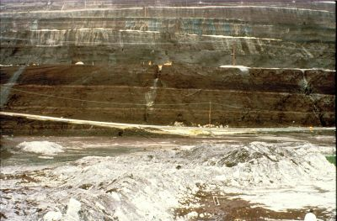Volcanic ash layers toward the top of a 150 m (500 ft) coal seam, and a pollen-rich layer in the middle.

Sinking the swamp theory
Most of the types of plants in the Latrobe Coal Measures still grow today. Though the slow-and-gradual theory insists they were fossilized in a swamp environment, the overwhelming majority is not swamp-tolerant.
Most of the plant material in Latrobe brown coal came from conifers,¹ a group including pines, spruces, and cedars. The following conifers have been identified in the coal:
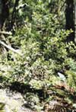Young Celery-top Pine by Don BattenBanksia flower by Don Batten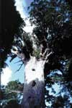Kauri tree by Andrew Snelling
- Araucaria. The Norfolk Island Pine (Araucaria heterophylla) is a well-known member of this genus, and is widely planted in coastal regions. It grows in sandy soils and tolerates sea spray. Araucaria are adaptable to a range of different soils but not waterlogged conditions.²
- Agathis. The Kauri Pine (Agathis robusta) is a well-known example. They grow up to 50 metres (160 feet) tall and are valued for their wood.³ Kauri Pines do not grow in swamps but prefer well-drained, deep, moist soils.⁴ In Queensland, Australia, they inhabit the drier margins of rainforests.
- Lagarostrobos. The Huon Pine (Lagarostrobos [previously Dacrydium] franklinii) is a native of Tasmania, Australia. Although it grows in moist soils near rivers, it needs good drainage. The slow-growing Huon Pine can exceed 40 metres (130 feet) in height.
- Phyllocladus. For example, the Celery-top Pine (Phyllocladus aspleniifolius) in Tasmania, Australia. This tree reaches up to 30 metres (100 feet), prefers cool, moist, well-composted soil, and a protected semi-shaded position. It does not grow in waterlogged conditions.²
- Podocarpus. The Brown Pine (Podocarpus elatus) is a member of this group that grows in coastal rain- and scrub-forests of eastern Australia.³ It is a large tree that grows up to 45 metres (150 feet) high. Members of this genus prefer well-drained soils, not swamp conditions.
Non-conifer plants have also been identified in the coal, including:
- Casuarina. Only two of the 30 or so species of Casuarina tolerate poor drainage. Only one, the Swamp She-oak (Casuarina paludosa), actually prefers swampy conditions. Most prefer light, well-drained soils.²
- Banksia. Only two of the 47 species of Banksia tolerate swampy conditions. Most species prefer well-drained conditions.³
- Nothofagus. The native New Zealand Red Beech (Nothofagus fusca, which grows to 30 metres) and the Silver Beech (Nothofagus menziesii) are cool-temperate rainforest trees which like moist soils in a protected, sunny position.⁵ They are found at high altitudes—1,000–3,000 metres (3,000–10,000 feet); they do not grow in swamps.²
It is clear that, overall, the plants identified in the brown coal are not the sorts that grow in wet, swampy conditions. Rather, most are drought tolerant, and grow at high altitudes, consistent with a huge watery catastrophe that swept vegetation together from a large geographical area. It was from the cones, seeds and plant debris of this catastrophe that the vegetation recolonized the islands and continents of the Southern hemisphere after the Flood.

Flood models and biblical realism
by Jonathan Sarfati
Biblical creationists by definition believe in a globe-covering flood. But how this occurred has been a matter of intense debate within the creationist geologist community. Some general observations can be made from a theological, philosophical, and scientific perspective.

Hold the Bible strongly; hold models loosely
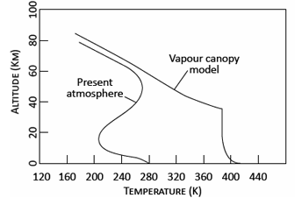Figure 1. Calculated vertical temperature profile for a vapour canopy model of the earth’s atmosphere compared with the temperature profile today (after Rush and Vardiman, ref. ⁶¹). Increased water in the canopy increases the surface temperature of the earth limiting the amount of precipitable water that can be feasibly stored.
The Bible, as God’s written word, should be non-negotiable. Its teachings are propositional truth, and must be the foundation for all our teachings, including about the Flood. This applies not only to explicit statements, but to anything logically deducible from these statements.¹ In fact, Jesus Himself endorsed the Flood as a real event, the Ark as a real ship, and Noah as a real person (Luke 17:26–27), so how can any of His professing followers deny it?
But where the Bible is genuinely silent, we are free to use science to help build models to help elucidate the clear teachings of Scripture. But these models are just man-made—they must never be given the same authority as Scripture. In any case, science is always changing, so being married to a model today will probably result in being widowed tomorrow. Worse, if the Bible is too tied up with a model later discarded, many will think that the Bible itself was refuted (cf. the church’s adoption of Aristotelian cosmology v Galileo^{2,3}).
Model-building should be an example of the ministerial use of science.
Model-building should be an example of the ministerial use of science. In contrast, the magisterial use of science, practised by all compromisers on Genesis, overrules the clear teaching of the Bible to come up with a meaning inconsistent with sound hermeneutics. Instead of the Reformation principle of Sola Scriptura (Scripture alone), this is Scriptura sub scientia (Scripture below science).⁴ With these principles, some popular ideas can be examined.

Pre-Flood paradise?
Many creationist works from a few decades ago portrayed the antediluvian world as a paradise, which was horribly spoiled at the Flood. But this is not taught in Scripture. Furthermore, it obscures the teaching that the big spoiling of paradise occurred at the Fall.⁵ This was the time that death, childbirth pain, and thorns and thistles were introduced, when Adam and Eve were tossed out of the Edenic paradise, and when the whole creation started groaning in pain.⁶
The only genuinely biblical evidence adduced for a pre-Flood paradise is that people before the Flood lived for over 900 years, while lifespans dropped exponentially after that. Yet Noah’s lifespan wasn’t shortened despite spending the last third of his life in the alleged ruined environment. Rather, in the 1990s, it was proposed that the decline in lifespans had genetic causes.⁷ Recent advanced computer programs vindicate this proposal, showing that an exponential decline of lifespans fits well with accumulating mutations after the catastrophic population bottleneck at the Flood.^{8,9,10,11}
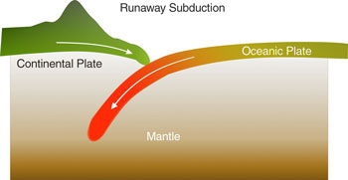Figure 2. In the catastrophic plate tectonics model, runaway subduction into the earth’s mantle of the oceanic plates drives the motion of the rigid lithosphere at metres per second.
The only remaining support for an environmental cause of the decreasing lifespan is Shem, born before the Flood bottleneck, but living only ⅔ as long as most of his ancestors. But here there is also a plausible genetic explanation: he was born when his father was 502,¹² i.e. over half-way through his lifespan. His ancestors were much younger when they begot their named sons.
It has long been known that children born to aged mothers have a higher risk of developing non-hereditary genetic disorders such as Down’s Syndrome, and it is plausible that Mrs Noah was about the same age as Noah. But even if she were much younger, more recent research points to aged fathers as a major source of genetic disorders. This should not be surprising since men keep producing sperm throughout their lives, and older men have more mutations.¹³
So it is not surprising that Shem, while very fit by today’s standards, would have been considerably less fit than his parents, and carried extra heritable mutations.

No rain before Flood?
Many older creationist models asserted that there was no rain or rainbow before the Flood, based on Genesis 2:5, “for the Lord God had not caused it to rain on the land”, and the Noahic Covenant in Genesis 9:13. This is supposed to result in a warmer and more even climate in the antediluvian world.
Yet the first passage is describing the situation before Man was created; it is silent on whether there was subsequent rain in the 1656 years before the Flood (Genesis 5). And there are plenty of examples in Scripture where God took pre-existing objects or actions and bestowed a new covenantal meaning on them. For example, bread and wine obviously pre-dated the Lord’s Supper.
Furthermore, the Bible gives no indication that the ‘laws of nature’ (really God’s regular ways of upholding His creation¹⁴) were any different before the Flood from what they are now. Yet they would have to be if there were no evaporation, precipitation and differential refraction before the Flood.

Higher atmospheric or oxygen partial pressure
One idea for the pre-Flood world, derived partly from the fallacious pre-Flood paradise assumption, is that oxygen concentration¹⁵ or atmospheric pressure was higher than today. This would supposedly have beneficial effects duplicated in today’s hyperbaric chambers. These increase the oxygen partial pressure¹⁶ as per Dalton’s Law.¹⁷
Yet would they be as beneficial as claimed, given the known health benefits of anti-oxidants? To be fair, evolutionists have also proposed higher oxygen concentration or higher atmospheric pressure in the past.¹⁸ This is supported by some scientific evidence, yet this does not hold up:¹⁹
Higher oxygen levels in amber air bubbles: yet they are not a closed system—gases diffuse in and out. Furthermore, contraction under solidification would shrink bubbles, thus raising pressure according to the law named after the creationist ‘father of modern chemistry’, Sir Robert Boyle (1627–1691), that gas pressure is inversely proportional to volume. Also, even the formation of bubbles in itself must increase pressure, to counteract the resistance of surface tension to producing the new surface area of the inside of the bubble. This excess Laplace pressure is given by the equation:
ΔP = ^{2γ}∕_{r}
where ΔP is excess pressure, or difference between inside and outside; γ = surface tension; r is bubble radius. This extra pressure is considerable in tiny bubbles, so the partial pressures would also be increased, according to Dalton’s Law.
Pterosaurs need high pressure to generate enough lift to fly: but previous models of pterosaur flight overlooked the function of the tiny pteroid bone, that would have supported a controllable flap. This would greatly increase lift in both takeoff and landing.^{20,21}
Gigantic insects could not have gained enough oxygen under normal pressure. The fossil record shows huge insects such as Meganeura, a dragonfly with a wingspan of 71 cm. For a long time, scientists thought that insects didn’t breathe, and oxygen diffused passively through holes (spiracles) through tiny tubes in the abdomen (tracheae). Since this could work only over very short distances, how could such a creature survive without extra oxygen?²² Yet recent synchrotron X-ray microscopy shows that insects really do ‘breathe’ by squeezing the tracheae, such that half the gas is exchanged every second.^{23,24}
This doesn’t disprove a higher oxygen concentration and air pressure, but it shows that they were not needed scientifically. They are definitely not needed on biblical grounds.

Meteorite impact
In the Bible, the first cause for the Flood was “all the fountains of the great deep burst forth” and the second was “the windows of the heavens were opened” (Genesis 7:11). Keil and Delitzsch comment:
“The same day were all the fountains of the great deep (תהום t^{e} hôm the unfathomable ocean) broken up, and the sluices (windows, lattices) of heaven opened, and there was (happened, came) pouring rain (גשם geshem) in distinction from מטר (mātār) upon the earth 40 days and 40 nights.’ Thus the flood was produced by the bursting forth of fountains hidden within the earth, which drove seas and rivers above their banks, and by rain which continued incessantly for 40 days and 40 nights.”²⁵
Thus the Flood began with fountains in the sea and other deep parts of the earth, and only secondarily from the rain. However, some Flood models involve a meteorite initiating the Flood. But this could never be derived from the biblical text, and is instead driven by ‘science’. But could it be acceptable anyway?
Certainly, there is strong evidence of large numbers of impacts on the earth and other solar system bodies. Further, the evidence from lunar craters—their location mainly in one quadrant and the ‘ghost’ craters^{26,27} —suggests that the main source of bombardment was a narrow meteoroid swarm that passed by before the moon had moved very far in a single orbit.²⁸ A likely time for this swarm was in the Flood year. Indeed, multiple impacts would provide sufficient energy to maintain the Flood, including causing much water (liquid and vapour) to shoot into the sky and return as rain. The Bible is genuinely silent on this, so such a model is biblically acceptable; whether it can solve all the geological problems is an ongoing question.²⁹
But a meteorite as an initiator of the Flood seems unacceptable. This contradicts the clear teaching that the Flood began deep within the ocean and underground, not the sky. Furthermore, this is not an argument from silence, but an argument from conspicuous absence. If a meteorite really were the primary cause, then why does Genesis not mention such a dramatic event? Elsewhere in Scripture, we have the description of “stars falling from heaven”,³⁰ and in both Hebrew and Greek, any bright heavenly object was called a ‘star’, including a ‘shooting star’. So one would expect Genesis 7:11 to read “a star fell from heaven, and all the fountains of the great deep burst forth … ”, or even “God cast a star down from heaven … ”.
In formal logical terms, an argument from conspicuous absence is a valid argument called denying the consequent (or modus tollens): if something as dramatic as a meteorite caused the Flood, then the Bible would have mentioned it. The Bible doesn’t mention it, therefore a meteorite didn’t cause the Flood. Conversely, an argument from silence is a logical fallacy called denying the antecedent: if the Bible had mentioned that Noah used nails to build the Ark, then Noah used nails; the Bible doesn’t mention nails, therefore Noah didn’t use them.³¹
One defence is that Noah didn’t see the meteorite, but only the resulting tsunamis, so the Bible recorded only the latter. But by the same token, would Noah have seen the happenings in the deep central ocean either? Even more serious, this is identical in principle to a major argument of local flood compromisers: the world was flooded as far as Noah could see, but it was still only regional. In any case, the Genesis Flood account was clearly a God’s-eye view, hence the revelation of the global character of the Flood by its repeated use of “all” (Hebrew כל kol), including the ‘double kol’ in Genesis 7:19.³²

Canopy theory
The canopy theory, as a model for the beginning of the Flood, aligns strongly with this ‘antediluvian paradise’ idea. This asserts that the ‘waters above’ referred to a canopy of water vapour, which condensed and collapsed to provide the rain for the Flood (figure 1). A few decades ago, this was very popular—for good reason, since it seemed to explain many things about rain, rainbows and longevity. Now it is rejected by most informed creationists.
However, the real problem was that some creationists gave the impression that it was a direct teaching of Scripture; CMI cautioned against such dogmatism back in 1989 when the model was still very popular among many creationist writers.³³ After all, for most of church history, no one had seen a canopy in the actual text of Scripture, yet God specifically wrote Scripture to teach, i.e. to be understandable (2 Timothy 3:15–17). Furthermore, it seems to contradict Scripture, since Psalm 148:4 says: “Praise him, you highest heavens, and you waters above the heavens!” Clearly these waters could not have been a canopy that collapsed during the Flood, since they were still present during the time of the Psalmist over a thousand years later.
Many of the arguments for the canopy were faulty on scientific grounds. For example, one argument is that the canopy would protect us from damaging radiation, and explain the extremely long lifespans. But water vapour is not a great shield for UV—you can be sunburned on a cloudy day and while swimming. When it comes to cosmic radiation, there is no evidence that this is involved in longevity, and as stated above, the cause of decreasing lifespans was genetic rather than environmental.
What water absorbs very well is infrared, as any vibrational spectroscopist knows.³⁴ It is actually a far more important ‘greenhouse gas’ than CO₂, accounting for about 66% of the atmospheric ‘greenhouse effect’ on Earth, or maybe even as much as 95%.³⁵ This leads to the major scientific problem with the canopy theory—a water vapour canopy thick enough to provide more than about a metre’s worth of floodwater would cook the earth.³⁶

Catastrophic plate tectonics
This is probably the most popular model among informed creationists today.³⁷ This accepts much of the evidence adduced to support uniformitarian plate tectonics, but solves a number of problems. The CPT model begins with a pre-Flood super-continent (possibly indicated by Genesis 1:9). While uniformitarian models assume that the ocean plates have always had the temperature profile they display today, the CPT model starts with some additional cold rock in regions just offshore surrounding the supercontinent. Since this rock was colder, it was denser than the mantle below. At the start of the Flood year, this began to sink (figure 2).
One problem with this created instability is that it would be a ticking time bomb. This is not necessarily an insuperable difficulty, though, since it is akin to the issue of (and answer to) “why are some features designed to hurt other things, if God created a world without death and suffering?” While some things can be explained as an adaptation from plant-eating structures, such as some teeth, other things cannot. A good example is jellyfish’s stinging cells with a catapult mechanism. Here, it is not adequate to claim that they once stung plants. Rather, since God foreknew the Fall, He programmed latent genetic information that would be switched on at the Fall.³⁸
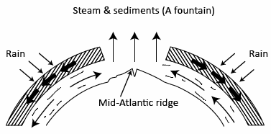Figure 3. In the hydroplate model rupture of the crust allows steam and sediment to be ejected as a fountain into the atmosphere, returning to the earth as rain (from Brown, ref. ⁶²).
But how can it sink more rapidly than ocean plate subducts today? The answer lies in laboratory experiments that show that the silicate minerals that make up the mantle can weaken dramatically, by factors of a billion or more, at mantle temperatures and stresses. If a cold blob of rock is sufficiently large, it can enter a regime in which the stresses in the envelope surrounding it become large enough to weaken the rock in that envelope, which allows the blob to sink faster, resulting in the stresses becoming a bit larger still, and causing the rock inside the surrounding envelope to weaken even more. Moreover, as the blob sinks ever faster, the volume of the envelope of weakened rock grows ever larger. Rather quickly the sinking velocity of the blob of dense rock can reach values of several km/hour, on the order of a billion times faster than is happening today. This is called runaway subduction.
The sinking ocean floor would drag the rest of the ocean floor along, in conveyor belt fashion, and would displace mantle material, starting large-scale movement throughout the entire mantle. However, as the ocean floor sank and rapidly subducted adjacent to the pre-Flood super-continent’s margins, elsewhere the earth’s crust would be under such tensional stress that it would be torn apart (rifted), breaking up both the pre-Flood super-continent and the ocean floor.
Thus, ocean plates separated along some 60,000 km where seafloor spreading was occurring. Within these spreading zones hot mantle material was rising to the surface to fill the gap caused by the rapidly separating plates. Being at the ocean bottom, this hot mantle material vapourized copious amounts of ocean water, producing a linear chain of superheated steam jets along the whole length of the spreading ridge system. This is consistent with the biblical description of the ‘fountains of the great deep’ (Genesis 7:11; 8:2). This steam would disperse, condensing in the atmosphere to fall as intense global rain (“and the flood-gates of heaven were opened”, Genesis 7:11). This could account for the rain persisting for 40 days and 40 nights (Genesis 7:12).
Not only is CPT backed up by supercomputer modelling that even impresses uniformitarians,³⁹ but it has also provided further fruitful research avenues for creationists, including a mechanism for Earth’s rapid magnetic field reversals⁴⁰ and hydrothermal solutions to carve huge caves.⁴¹ All the same, weather experts have been modelling the weather for decades, yet there are still many flaws; some argue that we should not place too much faith in modelling for plate tectonics either. Defenders argue that there are fewer unknowns in a confined solid state modelling of CPT than in the fluid (liquid and gas) dynamics and variable solar activity modelled in weather simulations.
Thus I think it is still the most promising theory, explaining the data supporting uniformitarian plate tectonics, and solving a number of its problems. That is why I have promoted it in my two largest books, Refuting Compromise (2004) and The Greatest Hoax on Earth? (2010). Its strong points include explaining high-pressure minerals and simultaneous uplift of all of today’s high mountains. Furthermore, under Uniformitarian PT, plates are moving too slowly to penetrate past the upper layers of the mantle; rather, they should blend in long before they reach the lower mantle. Yet studies show that the subducted plates have penetrated much further, and are still relatively cool. This is consistent with the subduction being fast enough to penetrate the mantle, and recently enough so they haven’t had time to heat up.
But CPT is not a direct teaching of Scripture, so it is legitimate for creationists to question or reject it as a model, and a number of knowledgeable creationist geologists do.^{42,43} Opponents argue that it concedes too much to uniformitarianism, and that it doesn’t explain the whole of the Flood, but only the last half.
Another problem that seems unsolved is getting rid of the excess heat. It is hardly satisfactory to suggest that God miraculously removed the heat. If one is going to resort to “God of the Gaps” reasoning⁴⁴ for a tiny part of the model, then why not just be done with a search for a mechanism and say, “God caused the Flood supernaturally”? After all, the Flood was a major disjunction in biblical history, and clearly a time of special intervention by God. Biblical creationists need not be closed to miraculous causes for such one-off, special events, rather than worry about ‘scientific’ rigour or ‘economy of miracles’. After all, we don’t need to find a quasi-naturalistic explanation for the Resurrection or feeding the 5,000. This is different from ordinary repeatable ‘operational’ science, where “God did it” is not acceptable.⁴⁵ Since models like CPT are trying to make an operational-science cause of the Flood, an ad hoc appeal to the miraculous is likewise unacceptable, unlike saying that the whole thing was miraculous.

Hydroplate
This model of Dr Walter Brown⁴⁶ has many passionate supporters. Brown explains:
“Before the global flood, considerable water was under the earth’s crust. Pressure increases in this subterranean water ruptured that crust, breaking it into plates. The escaping water flooded the earth. Because hydro means water, those crustal plates will be called hydroplates.”
Furthermore, water and rocks were hurled at speeds exceeding escape velocity, so this explains the origin of comets, asteroids and meteorites (figure 3).⁴⁷
The origin of the Flood under the ocean is a biblical strength of the model. Furthermore, ‘the Flood caused meteors’ lacks the biblical weakness of ‘meteor caused the Flood’. Yet it has failed to attract the support of many creationist geologists and geophysicists, many of whom have no reason to reject a successful flood model.
Furthermore, few creationist astronomers would accept an Earth origin for comets, meteors and asteroids. The Bible doesn’t require it and it is scientifically suspect—reaching Earth’s escape velocity of 11.2 km/s would be hard enough, and such objects would burn in the atmosphere. Note that our spacecrafts are launched in stages: first, they are taken up to a low earth orbit, where the speed is about 8 km/s. Then another stage accelerates the craft to escape velocity, which is a little lower as it is further from Earth’s gravity—about 10.9 km/s. But to launch comets into orbits reaching beyond Pluto would require speeds just a little less than the escape velocity with respect to the sun’s gravity at the earth’s orbit, or 42.1 km/s—and that’s after overcoming atmospheric resistance. Note that the Voyager space probes were able to move past Pluto only by using “gravitational slingshots” of handily aligned planets to augment their speeds.
The Journal of Creation has published an article about various Flood models, including the hydroplate, which was treated neutrally.⁴⁸ But for the creationist community to take it further, Dr Brown should publish it in a journal such as this, and respond to criticisms from creationist experts in geology, e.g. that there is more water still inside the mantle than in the oceans.⁴⁹ A forum similar to a previous one on CPT⁵⁰ would be most instructive.

‘Vanishing Flood’ models
The Bible doesn’t directly teach anything about the pre-Flood and post-Flood boundaries. It doesn’t even directly teach that fossils and rocks are the result of the Flood. Yet 2 Peter 3:3–6 is an important passage:
“Scoffers will … deliberately ignore this fact, … the world that then existed was deluged with water and perished.”
This strongly implies that the Flood must have left some dramatic evidence, otherwise why would scoffers be held culpable for “deliberately ignoring” the fact of the Flood if there is no evidence? By similar reasoning, Romans 1:18–22 is a good argument against theistic evolution. Verse 20 says:
“Ever since the creation of the world his invisible nature, namely, his eternal power and deity, has been clearly perceived in the things that have been made. So they are without excuse.”
This passage clearly teaches that unbelievers won’t have the slightest excuse for unbelief, because God’s power and deity can be “clearly seen” from nature. This seems to be a strong support for the argument from design. However, according to Gould, one of Darwin’s main motivations was to counteract the argument from design.⁵¹ So if evolution were true, or that there was “gobs of evidence” for it as one professing creationist recently asserted,⁵² then where is the clear evidence for God’s power from what has been made? Far from being evidence for a divine hand, evolution, according to Gould, gives ‘evidence’ that “there’s nothing else going on out there—just organisms struggling to pass their genes on to the next generation. That’s it.” So once again, if evolution were true, there is no evidence for a God from what has been made, but evidence only for ruthless struggle for existence. So why would unbelievers be “without excuse” if evolution were true?
The same applies to the uniformitarianism of Flood scoffers, such as Darwin’s mentor Charles Lyell who tried to “free the science [of geology] from Moses”.⁵³ Widespread fossils of soft-bodied creatures and huge animals, as well as wide and flat sedimentary layers certainly fit the bill. Thus this passage rules out certain extreme versions of the ‘Anglo-European’ or ‘Recolonization’ Flood Model, which become ‘vanishing Flood’ models, where most of the geology of the earth formed after the Flood.^{54,55} And of course, this would rule out the view of certain ‘progressive creationists’ such as Hugh Ross that the Flood was local and left no traces.⁵⁶

Tas Walker’s ‘Biblical Geology’ model
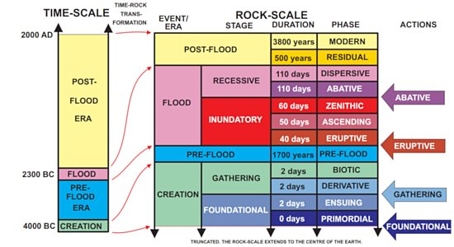Figure 4. The Biblical Geologic Model is a geologic classification scheme based on the biblical record of Earth history. The model is useful for classifying geologic data, understanding geologic processes and guiding geologic research. It is a powerful tool for communicating biblical geologic concepts.
So, given that the Flood left behind considerable evidence, as this passage teaches, what can be predicted? Walker has proposed a geological framework (although not an explanation of the Flood per se) by which to understand rock layers and fossils, not just for the Flood year, but for all of Earth history—from the Creation Week to the present time (figure 4). He did this by using the clear descriptions of Scripture, as well as more loosely holding inferences from what we think we know about sedimentology and hydrology.
Since the Bible clearly teaches that the waters rose to cover the whole earth, then retreated, Walker proposes two main stages of the Flood ‘year’ (really 370 days): ‘inundatory’ and ‘recessive’. There might be some minor deviations, since variations in topography, floodwater and chemistry, mean that the results of Flood processes might not be strictly synchronous, even though the rocks produced might be the same.
The former is subdivided further: the earliest is the ‘eruptive phase’, derived from the explosive implications of the “fountains of the great deep bursting forth”; second, ‘ascending phase’, derived from the waters “increasing” upon the Earth (Genesis 7:17–18); third, the ‘zenithic’, from the biblical teaching of the Flood waters “prevailing” for so long with the mountains all covered, as well as the common-sense observation that the waters must have peaked some time.
The latter (‘recessive’) stage is subdivided not according to Scripture per se, but according to hydrological observations (which is why it is called a model).⁵⁷ First, large amounts of water moving off a surface that was wholly submerged would first start to flow in huge sheets. This phase is called ‘abative’. Then, as the water level dropped and land emerged, the flow would be divided into large channels, hence the ‘dispersive’ phase.
Where the Bible is truly silent, one is free to invoke known phenomena, but models involving these should be held loosely.
This makes good sense of many geological features hard to explain under uniformitarian models,⁵⁸ of which I will mention two. First, planation surfaces, which look like someone had taken a giant plane over the surface and shaved it flat, regardless of orientation or hardness. This is just what a giant sheet of water would do in the abative phase.⁵⁹ Second, water gaps: instead of rivers following the path of least resistance around mountains, many go through gaps in them. This is consistent with violent channelized flow of huge volumes of water overtopping perpendicular barriers and carving channels straight through them. Since water gaps were formed after much erosion had occurred, they are consistent with having been formed in a later stage of the recessive stage.⁶⁰
Verified predictions are a strength of a model, but they cannot logically be considered a proof—that would be a logical fallacy called affirming the consequent.¹

Conclusion
The biblical global Flood is a vital teaching of Scripture, and essential for understanding Earth history. Yet we were not there, so trying to understand it has a number of difficulties. So it is not surprising that there are a number of different creationist proposals, and a few errors in some.
The starting point must be the explicit statements of Scripture, and propositions that logically follow from them. Since the Flood was a historical event, then our description of its details is at heart historical.
For finding out the details, science is useful as a forensic tool, but is not the driving discipline. This can show how known processes in hydrology and sedimentology would work under the constraints of the biblically-derived propositions. Where the Bible is truly silent, one is free to invoke known phenomena, but models involving these should be held loosely.
With so many unknowns, it is not surprising that there are a number of different models. But multiple models are a good thing in science, especially when it comes to trying to understand what happened in the unobservable past. What ultimately matters is what is true, not what fits a particular scientific model.

The global flood—according to the New Testament
by Lita Sanders
Wikimedia: Richard Wang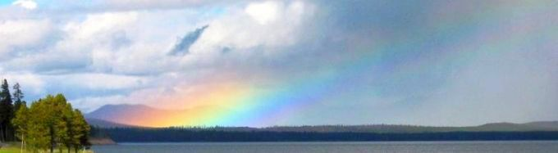
Many Bible skeptics regard Genesis 1–11 as mythical, copied from Enuma Elish, the Epic of Gilgamesh, and other such ancient writings—so not only is it a primitive myth, it’s not a particularly original one, in their view. We’ve often written about the characteristics of Genesis that show it claims to record history.
Sadly many believers have bought into various compromising interpretations of the Flood narrative, but as Christians, aren’t we supposed to believe what Jesus did? And it’s easy to extend that to believing what the apostles that He appointed and inspired by the Holy Spirit to author Scripture believed as well. If Christians don’t believe the Bible, in what sense are they ‘Christ followers’? So let’s look at what Jesus believed and what the New Testament tells us about the circumstances surrounding Noah’s Flood.

The world at the time of Noah
In Noah’s day, Jesus tells us that people were going about conducting ‘business as usual’ until the Flood came: “in those days before the flood they were eating and drinking, marrying and giving in marriage, until the day Noah entered the ark, and they were unaware until the flood came and swept them all away” (Matthew 24:38–39). But it wasn’t a pleasant place to live—the culture was so immoral that Peter called it “the world of the ungodly” (κοσμῳ ἀσεβῶν, kosmō asebōn, 2 Peter 2:5). There were even angels who sinned at that time (2 Peter 2:4) by deserting their proper positions (Jude 1:11). While the New Testament doesn’t specify exactly what this sin was, it fits in nicely with the assertion in Genesis 6 that the ‘sons of God’ took wives among the ‘daughters of men’—in other words, angels taking human wives¹ and fathering the Nephilim.

The Ark and its passengers
The author of Hebrews says: “By faith Noah, being warned by God concerning events as yet unseen, in reverent fear constructed an ark for the saving of his household. By this he condemned the world and became an heir of righteousness that comes by faith” (11:7). Peter says that only eight people were saved in the Ark (1 Peter 3:20): Noah and seven others (2 Peter 2:5). Absolutely everyone else was killed in the Flood (Luke 17:27).
The New Testament authors rarely reference the Old Testament for its own sake—they assume basic belief of the Old Testament Scriptures—rather, they are raising the historical events to use as examples or precedents to support their theological arguments.

The extent of the Flood
The Flood of Noah destroyed the entire human civilization that existed at that time (Matthew 24:39; Luke 17:27; 2 Peter 2:5; 3:5–6). The scope was global, and so severe that the earth was, in effect, reversed to its state on Day 2, before God created dry land—the whole earth was covered with water. This is strongly stated by 2 Peter 3:6, which says that the kosmos was destroyed in the Flood, pointing to its global extent:
What was destroyed was “the world of that time,” which contrasts with “the present heavens and earth” that are mentioned in the next verse. While the focus of the destruction is certainly on the human beings inhabiting that world … the destruction extended to the whole “world” as the merging waters undid the work of Gen 1:6–10, returning the creation to a watery chaos and concomitantly destroying those living things that were created after Gen 1:10.²
So not only was the Flood anthropologically universal, as most ‘progressive creationists’ would allow, but according to the New Testament it was global.

The promise
A rainbow surrounds God’s throne in Heaven (Revelation 4:3) as a constant reminder of His promise to Noah never to flood the earth again. The concept of a global Flood is often ridiculed not only by secularists, but also by Christians who doubt its historicity. But God promised not to send another Flood like the one He sent in Noah’s day. If it was just an extremely disastrous local Flood, God would have broken His promise because there have been innumerable catastrophic local floods.

New Testament theology of the Flood
The New Testament authors rarely reference the Old Testament for its own sake—they assume basic belief of the Old Testament Scriptures—rather, they are raising the historical events to use as examples or precedents to support their theological arguments. This is why a lot of the details of the story of Noah’s flood aren’t found in the New Testament (if you just had the New Testament, for example, you wouldn’t know that there were any animals on the Ark!). But silence should always be interpreted as agreement unless there is a compelling reason to do otherwise.
So the New Testament authors take Genesis as history, but revealingly, they take it as more than history at the same time.
So the New Testament authors take Genesis as history, but revealingly, they take it as more than history at the same time. Because Genesis 1–11 is primarily about God’s actions in Earth’s and humanity’s earliest history, the New Testament authors are primarily interested in what these events tell us about God (note this doesn’t mean that the history is less important).
God’s righteousness is clearly on display in the Flood narrative—He judges angels as well as people when they sin (2 Peter 2:4; Jude 1:6), but He spares the righteous (2 Peter 2:5). Peter used the Flood story to teach that God is equally capable of judging sin and preserving the righteous in today’s world as He was in Noah’s day (2 Peter 2:9–10).
Even so, He is patient in His judgment—just as God was patient in waiting for Noah to complete the Ark’s construction, today God is patiently waiting so that more people can come to faith in Jesus (2 Peter 3). But this doesn’t mean that people should be complacent. Jesus taught that just as people didn’t expect the Flood, His coming will be sudden and unexpected (Matthew 24, Luke 17), and it will be too late for those who didn’t believe while there was still time. As one commentator notes:
The people could see Noah building his ark, and doubtless, human nature being what it is, some mocked him. But they knew nothing; they did not share in Noah’s wholehearted commitment to the service of God, so they did not know what was coming on the earth. They disregarded what Noah said to them, doubtless believing firmly that their views were just as valid and just as likely to be correct as those of the ark maker. But such convictions did not avail when the Flood came and took them all away. The purposes of God are worked out quite irrespective of what puny humans think about them. Jesus is saying that people will in this way continue to be about their normal business right up to the time of his coming. That will be the critical point; after that it will be too late, just as it was too late for the antediluvians when the Flood came. The coming of the Son of man will be just as abrupt, just as unexpected, just as decisive as the coming of the Flood was.³

Christian theology is tied to history
While a lot of modern people want to separate theology from history, in the New Testament the two are inextricably tied together. The history doesn’t mean anything unless it’s interpreted correctly, and the theology has no foundation if the history isn’t accurate. Each time the New Testament authors cite a historical fact, it’s to give a precedent for how God has worked in the past. There’s nowhere where a NT author says simply, “Noah built an ark to escape a worldwide flood” with the purpose of getting the audience to believe just that. Christians writing to Christians assumed that they would believe the Scriptures. Rather, the historical points are used to support the theology that the author is teaching, such as ‘God judged the world once, so don’t think that He won’t do it again!”
What this means is that if we reject the history that the NT authors accepted, their theological arguments have no weight whatsoever. It seems illogical to say, “Peter was wrong about a global Flood in which only the passengers of the Ark survived, but his theology is still accurate.”
We should be encouraged that the New Testament authors placed such a great confidence in the Bible’s history, and that should inspire us to be equally as confident.

New Testament references to the Flood
Matthew 24:37–39 | “For as were the days of Noah, so will be the coming of the Son of Man. For as in those days before the flood they were eating and drinking, marrying and giving in marriage, until the day when Noah entered the ark, and they were unaware until the flood came and swept them all away, so will be the coming of the Son of Man.”
Luke 17:26–27 | “Just as it was in the days of Noah, so will it be in the days of the Son of Man. They were eating and drinking and marrying and being given in marriage, until the day when Noah entered the ark, and the flood came and destroyed them all.”
Hebrews 11:7 | “By faith Noah, being warned by God concerning events as yet unseen, in reverent fear constructed an ark for the saving of his household. By this he condemned the world and became an heir of the righteousness that comes by faith.”
1 Peter 3:20 | “… because they formerly did not obey, when God’s patience waited in the days of Noah, while the ark was being prepared, in which a few, that is, eight persons, were brought safely through water.”
2 Peter 3:5–6 | “For they deliberately overlook this fact, that the heavens existed long ago, and the earth was formed out of water and through water by the word of God, and that by means of these the world that then existed was deluged with water and perished.”
2 Peter 2:4–5 | “For if God did not spare angels when they sinned, but cast them into hell and committed them to chains of gloomy darkness to be kept until the judgment; if he did not spare the ancient world, but preserved Noah, a herald of righteousness, with seven others, when he brought a flood upon the world of the ungodly.”
Jude 1:6 | “And the angels who did not stay within their own position of authority, but left their proper dwelling, he has kept in eternal chains under gloomy darkness until the judgment of the great day.”
Revelation 4:3 | “And he who sat there had the appearance of jasper and carnelian, and around the throne was a rainbow that had the appearance of an emerald.”

Was the Flood global?

Creation Answers Book (8th ed. 2019), Chapter 10

Contents

Chapter 1Does God exist?

Chapter 2Six days? Really?

Chapter 3What about gap theories?

Chapter 4What about carbon dating?

Chapter 5How can we see distant stars in a young universe?

Chapter 6How did bad things come about?

Chapter 7What about similarities and other such arguments for evolution?

Chapter 8Who was Cain’s wife?

Chapter 9Were the ‘sons of God’ and/or the nephilim extraterrestrials?

Chapter 10Was the Flood global?

Chapter 11What about continental drift?

Chapter 12Noah’s Flood-what about all that water?

Chapter 13How did all the animals fit on Noah’s Ark?

Chapter 14How did freshwater and saltwater fish survive the Flood?

Chapter 15Where are all the human fossils?

Chapter 16What about ice ages?

Chapter 17How did animals get to Australia?

Chapter 18How did all the different ‘races’ arise (from Noah’s family)?

Chapter 19What about dinosaurs?

Chapter 20What should I do?
- Does it matter?
- Does the Bible say that Noah’s Flood covered the whole earth?
- Is there any evidence outside the Bible for such a Flood?
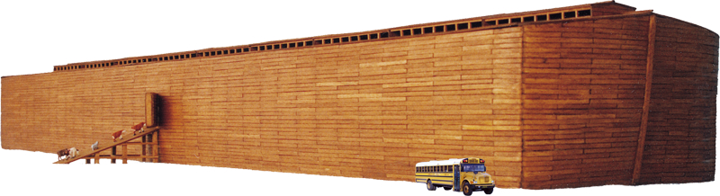The size of the Ark makes sense only if the Flood were global.
Many Christians today claim that the Flood of Noah’s time was only a local flood. They claim it was confined to somewhere around the Mesopotamian region and never really covered the whole earth. The discovery of a layer of mud by archaeologists in the Middle East and more recently the finding of evidence for a local flood in the Black Sea have both been claimed as evidence for a (local) biblical flood.
People generally want a local flood because they have accepted the widely believed evolutionary history of the Earth, which interprets the fossils under our feet as the history of the sequential appearance of life over eons of time.
If the Flood were local, why did Noah have to build an Ark? God could have simply warned Noah to flee, as He did for Lot in Sodom.
Scientists once understood the fossils (which are buried in water-carried sediments of mud and sand) to be mostly the result of the great Flood. Those who now accept the evolutionary billions of years of gradual accumulation of fossils have, in their way of thinking, explained away the evidence for the Flood—hence their belief in a local flood, or none at all. If they would think from a biblical perspective, they would see the abundant evidence for the Flood. As someone quipped, “I wouldn’t have seen it if I hadn’t believed it.”
Those who accept the eons of time with its fossil accumulation also, perhaps unwittingly, rob the Fall of its serious consequences. They put the fossils, which testify of disease, suffering, and death before mankind appeared, before Adam and Eve sinned and brought death and suffering into the world. In doing this they also undermine the meaning of the death and Resurrection of Christ. Such a scenario also robs God’s description of His finished creation as ‘very good’ of all meaning (see Chapter 2).
Some preachers will say they believe in a ‘universal’ or ‘worldwide’ flood, but really they do not believe that the Flood covered the whole earth. They side-step the clear teaching of the Bible, while giving the appearance of believing it, by cleverly redefining words. They mean ‘universal’ and ‘worldwide’ only in terms of an imagined limited extent of human habitation at the time. They imagine that people lived only, say, in a valley in Mesopotamia and so the flood could kill all the people without being global in extent.

Biblical evidence for the global Flood
The local flood idea is totally inconsistent with the Bible, as the following points demonstrate:

The need for the Ark
If the Flood were local, why did Noah have to build an Ark? He could have walked to the other side of the mountains and escaped. Travelling just 20 km per day, Noah and his family could have travelled over 3,000 km in six months. God could have simply warned Noah to flee, as He did for Lot in Sodom.

The size of the Ark
If the Flood were local, why was the Ark big enough to hold all the different kinds of land vertebrate animals in the world? If only Mesopotamian animals were aboard, or only domestic animals, the Ark could have been much smaller.¹

The need for animals to be on the Ark
If the Flood were local, why did God send the animals to the Ark to escape death? There would have been other animals to reproduce those kinds even if they had all died in the local area. Or He could have sent them to a non-flooded region.

The need for birds to be on the Ark
If the Flood were local, why would birds have been sent on board? These could simply have winged across to far-distant higher ground. Birds can fly several hundred kilometres in one day.

The judgment was universal.
If the Flood were local, people who did not happen to be living in the vicinity would not have been affected by it. They would have escaped God’s judgment on sin. It boggles the mind to believe that, after all those centuries since creation, no one had migrated to other parts—or that people living on the periphery of such a local flood would not have moved to the adjoining high ground rather than be drowned. Jesus stated that the Flood killed everyone not on the Ark (Matt. 24:37–39).
Of course those who want to believe in a local flood generally say that the world is old and that people were here for many tens of thousands of years before the Flood. If this were the case, it is inconceivable that all the people could have fitted in a localized valley in Mesopotamia, for example, or that they had not migrated further afield as the population grew.

The Flood was a type of the judgment to come.
In 2 Peter 3, the coming universal judgment by fire is likened to the judgment by water of Noah’s Flood: the world that then existed was deluged with water and perished. But by the same word the heavens and earth that now exist are stored up for fire, being kept until the day of judgment and destruction of the ungodly (verses 6 & 7).

The waters were above the mountains.
If the Flood were local, how could the waters rise to 15 cubits (8 metres) above the mountains (Gen. 7:20)? Water seeks its own level. It could not rise to cover the local mountains while leaving the rest of the world untouched.²

The duration of the Flood
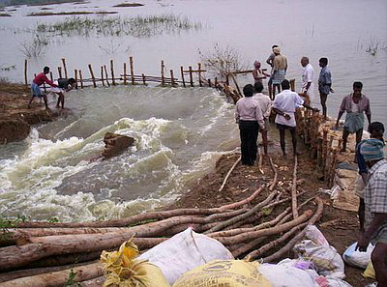Floodwater entering the roads of Chennai, India. If Noah’s Flood was only local, what would God’s promise not to send a flood again mean?
Noah and company were on the Ark for one year and 10 days (Gen. 7:11, 8:14)—surely an excessive amount of time for any local flood? It was more than seven months before the tops of any mountains became visible. How could they drift around in a local flood for that long without seeing any mountains?

God’s promise broken?
If the Flood were local, God would have repeatedly broken His promise never to send such a Flood again. There have been huge ‘local’ floods in recent times: in Bangladesh, for example, where 80% of that country has been inundated, or in Europe in 2002.

All people are descendants of Noah and his family.
The genealogies of Adam (Gen. 4:17–26, 5:1–31) and Noah (Gen. 10:1–32) are exclusive—they tell us that all the pre-Flood people came from Adam and all the post-Flood people came from Noah. The descendants of Noah were all living together at Babel and refusing to “fill the earth”, as they had been commanded (Gen. 9:1). So God confused their one language into many and scattered them (Gen. 11:1–9).
There is striking evidence that all peoples on Earth have come from Noah, found in the Flood stories from many cultures around the world—North and South America, South Sea Islands, Australia, Papua New Guinea, Japan, China, India, the Middle East, Europe, and Africa. Hundreds of such stories have been gathered.³ The stories closest to the area of dispersion from Babel are nearest in detail to the biblical account—for example, the Gilgamesh epic.

The Hebrew terminology of Genesis 6–9⁴
·“The earth” (Heb. erets) is used 46 times in the Flood account in Genesis 6–9, as well as in Genesis 1. The explicit link to the big picture of creation, especially in Genesis 6:6–7, clearly implies a universal Flood. Furthermore, the judgment of God is pronounced not just on all flesh, but on the earth:
“And God said to Noah, The end of all flesh has come before me, for the earth is filled with violence through them. And, behold, I will destroy them with the earth.” (Gen. 6:13).
·“Upon the face of all the earth” (Gen. 7:3, 8:9) clearly connects with the same phrase in the creation account where Adam and Eve are given the plants on Earth to eat (Gen. 1:29). Clearly, in God’s decree the mandate is universal—the whole Earth is their domain. God uses the phrase in Genesis also of the dispersal of people at the Tower of Babel (Gen. 11:8–9)—again, the context is the whole land surface of the globe. The exact phrase is used nowhere else in Genesis.
·“Face of the ground”, used five times in the Flood account, also connects back to the universal context of creation (Gen. 2:6), again emphasizing the universality of the Flood.
·“All flesh” (Heb. kol-basar) is used 12 times in the Flood account and nowhere else in Genesis. God said He would destroy “all flesh”, apart from those on the Ark (Gen. 6:13,17),⁵ and He did (Gen. 7:21–22). In the context of the Flood, ‘all flesh’ clearly includes all nostril-breathing land animals as well as mankind—see Genesis 7:21–23. ‘All flesh’ could not have been confined to a Mesopotamian valley.
·“Every living thing” (Heb. kol chai) is again used in the Flood account (Gen. 6:19, 8:1,17) and in the creation account (Gen. 1:28). In the creation account the phrase is used in the context of Adam and Eve’s dominion over the animals. God said (Gen. 7:4) that He would destroy “every living thing” He had made and this happened—only Noah and those with him on the Ark survived (Gen. 7:23).
·“Under the whole heaven” (Gen. 7:19) is used six times outside of the Flood account in the Old Testament, and always with a universal meaning (Deut. 2:25, 4:19, Job 28:24, 37:3, 41:11, Dan. 9:12). For example, “Whatever is under the whole heaven is mine”, said the Lord (Job 41:11).
·A special Hebrew word was reserved for the Flood or Deluge: Mabbul. In every one of the 13 occasions this word is used, it refers to Noah’s Flood.
·“All the fountains of the great deep.” The fountains of the great deep are mentioned only in the Flood account (Gen. 7:11, 8:2) and Proverbs 8:28. ‘The deep’ (Heb. tehom) relates back to creation (Gen. 1:2) where it refers to the one ocean covering the whole world before the land was formed. And it was not just “the fountains of the great deep” but “all the fountains of the great deep” which broke open.
·A special Hebrew word was reserved for the Flood or Deluge: Mabbul. In every one of the 13 occasions this word is used, it refers to Noah’s Flood. Its one use outside of Genesis, Psalm 29:10, refers to the universal sovereignty of God in presiding over the Deluge. The New Testament also has a special word reserved for the Flood, cataclysmos, from which we derive our English word ‘cataclysm’.

The decrees in Genesis 9 parallel those in Genesis 1.
In Genesis 9:1 God gives man the exact same commission as in Genesis 1:28—“Be fruitful and multiply and fill the earth”. He also gives man dominion over “every beast of the earth” (Gen. 9:2, cf. 1:28) and man is instructed as to what he can and cannot eat (Gen. 9:4–5), which parallels Genesis 1:29–30. These decrees in Genesis 1 are universal in extent, and clearly they are also here, after the Flood. If Adam and his descendants were to rule the whole earth, so were Noah and his descendants. If ‘earth’ in Genesis 9:1 is the whole earth, as all would agree it is, then surely it is also the whole earth in the context of the Flood in Genesis 8:13!⁶

The New Testament speaks of the Flood as global
New Testament passages which speak of the Flood use universal language: “the flood came and took them all away” (Jesus, Matt. 24:39); “the flood came and destroyed them all” (Jesus, in Luke 17:27); “did not spare the ancient world [Greek: kosmos], but preserved Noah, a preacher of righteousness, and seven others, bringing in the flood upon the world of the ungodly” (2 Pet. 2:5); “a few, that is eight people, were saved through the water” (1 Pet. 3:20); Noah “condemned the world” through his faith in God (Heb. 11:7); “the world that then was, being flooded by water, perished” (2 Pet. 3:6). All these statements presuppose a global Flood, not some localized event.

Answers to objections to a global Flood

Objection 1: ‘All’ does not always mean ‘all’⁷
Some have argued that since ‘all’ does not always mean ‘each and every’ (e.g. Mark 1:5) the use of ‘all’ in the Flood account does not necessarily mean the Flood was universal. That is, they claim that this use of ‘all’ allows for a local flood.
In Genesis 7:19 we read that “all (Heb. kol) the high mountains under all (Heb. kol) the heavens were covered”. Note the double use of ‘all’, which clearly teaches the universality of the Flood.
However, the meaning of a word is decided by the context. From the context of ‘all’ in Luke 2:1, for example, we can see that ‘all the world’ meant all the Roman Empire. So, it is the context that tells us that ‘all’ here does not mean every bit of the whole land surface of the globe.
Similarly, to determine the meaning of ‘all’ in Genesis 6–9, we must consider the context, not just transfer the inferred meaning from somewhere else.
The word ‘all’ (Heb. kol) is used 72 times in the 85 verses of Genesis 6–9, 21% of all the times it is used in all 50 chapters of Genesis.
In Genesis 7:19 we read that “all (Heb. kol) the high mountains under all (Heb. kol) the heavens were covered”. Note the double use of ‘all’. In Hebrew this gives emphasis so as to eliminate any possibility of ambiguity.⁷ This could be accurately translated as “all the high mountains under the entire heavens”, to reflect the emphasis in the Hebrew. Leupold, in his authoritative commentary on Genesis, said of this, “… the text disposes of the question of the universality of the Flood.”⁸

Objection 2: The post-Flood geography is the same as the pre-Flood
Because the Tigris and Euphrates rivers were mentioned in the description of the Garden of Eden, and we have the Tigris and Euphrates rivers now, some have argued that the Flood could not have altered the topography of the world, and therefore it must have been local.⁹
However, there are major differences in the topography described for the Garden of Eden and the world now. There was one river flowing from Eden which separated into four rivers (Gen. 2:10–14), two of which were called the Tigris and the Euphrates. So the rivers had a common source before the Flood, which is very different from today. The other two rivers were the Pishon and the Gihon. The Pishon is not mentioned post-Flood and Gihon is used of the locality of a spring near Jerusalem in the times of Kings David, Solomon, and Hezekiah.¹⁰
The post-Flood world is not the same as the pre-Flood world. Someone may ask, ‘Then why do we have a Tigris and Euphrates today?’ Answer: the same reason there is a Liverpool and Newcastle in Australia; and a London, Oxford, and Cambridge in North America, although they were originally place names in England. Features in the post-Flood world were given names familiar to those who survived the Flood.

Objection 3: There is no evidence for such a Flood in the geologic record
What evidence would one expect from a global watery cataclysm that drowned the animals, birds, and people not on the Ark? All around the world, in rock layer after rock layer, we find billions of dead things that have been buried in water-carried mud and sand. Their state of preservation frequently tells of rapid burial and fossilization, just like one would expect in such a flood.
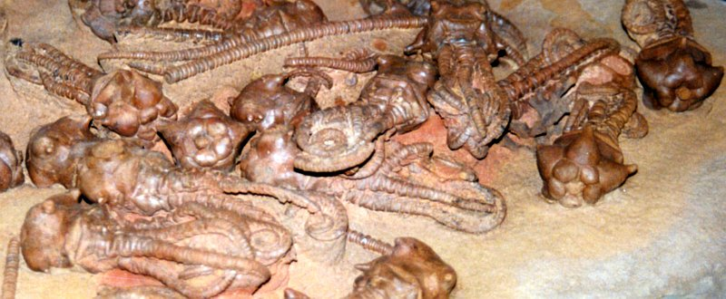Fossil ‘graveyards’ around the world, where the bones of many animals were washed together, buried and fossilized, are evidence for a watery cataclysm like the Flood.
There is abundant evidence that many of the rock strata were laid down quickly, one after the other, without significant time breaks between them. Preservation of animal tracks, ripple marks, and even raindrop marks testifies to rapid covering of these features to enable their preservation. Polystrate fossils (ones which traverse many strata) speak of very quick deposition of the strata. The scarcity of erosion, soil formation, animal burrows, and roots between layers also shows they must have been deposited in quick succession. The radical deformation of thick layers of sediment without evidence of cracking or melting also shows how all the layers must have been still soft when they were bent. Dykes (walls) and pipes (cylinders) of sandstone which connect with the same material many layers beneath show that the layers beneath must have been still soft, and contained much water. That the sandstone could be squeezed up through cracks above to form the ‘clastic’ dykes and pipes, again shows rapid deposition of many strata.
Many of the rock strata were laid down quickly without significant time breaks between them. Preservation of animal tracks, ripple marks, and even raindrop marks testifies to rapid covering of these features to enable their preservation.
The worldwide distribution of many geological features and rock types is also consistent with a global Flood. The Morrison Formation is a layer of sedimentary rock that extends from Texas to Canada, clearly showing the fallacy of the still-popular belief that ‘the present is the key to the past’—there are no processes occurring on Earth today that are laying down such large areas of sedimentary layers. In reality, God’s revelation about the past is the key to understanding the present.
The limited geographic extent of unconformities (clear breaks in the sequence of deposition with different tilting of layers, etc.) is also consistent with the reality of the global Flood. And there are many other evidences for the Flood.^{11,12}
The problem is not the evidence but the mindset of those looking at the evidence. One geologist testified how he never saw any evidence for the Flood—until, as a Christian, he was convinced from the Bible that the Flood must have been a global cataclysm. Now he sees the evidence everywhere. The Bible talks about people being corrupted in their thinking after turning their backs on God (Romans 1:18ff.) and of people being so spiritually blind that they cannot see the obvious (Acts 28:25–27).
Don Batten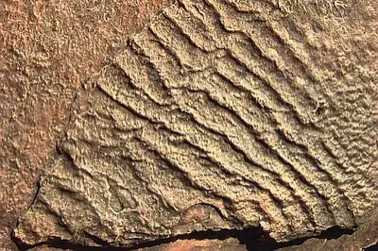Don Batten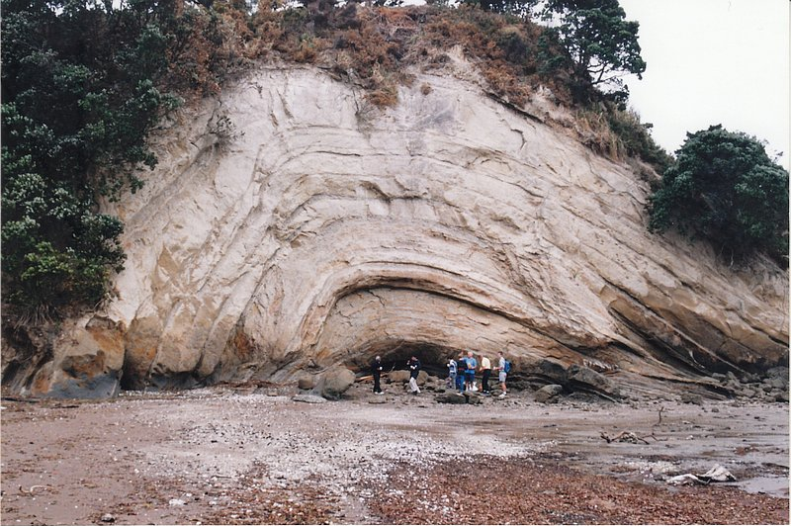
Preservation of ripple marks (left) requires rapid burial, as in the Flood (lower Triassic rock, England). Folding of sedimentary rock without cracking or heating (right), such as at Eastern Beach, Auckland, New Zealand, suggests the folding occurred before the sand and mud had time to turn into stone, consistent with rapid deposition during the Flood (note people for scale).

Conclusion
A universal worldwide, globe-covering Flood is clearly taught by the Bible. The only reasons for thinking the Flood was otherwise come from outside the Bible. When we use the framework provided by the Bible we find that the physical evidence from the rocks and fossils beautifully fits what the Bible says.¹³
Furthermore, the realization of the reality of God’s judgment by the Flood in the past should warn us of the reality of the judgment to come—a judgment by fire—and stimulate us to be ready for that judgment (2 Peter 3:3–13). Those who are not ‘in Christ’ will suffer the wrath of God (John 3:36).

The ‘Great Unconformity’ and associated geochemical evidence for Noahic Flood erosion
by Harry Dickens
The Bible’s Flood account describes the greatest rain event ever recorded. Forty days and nights of rain falling on the earth (Genesis 7:12) would have caused immense denudation of landmasses around the globe. Evidence for this is provided by a key stratigraphic surface and by associated geochemical signatures.

Nature and extent of the ‘Great Unconformity’
The term ‘Great Unconformity’ was originally used to describe the prominent stratigraphic surface exposed in the Grand Canyon that separates the Lower Cambrian Tapeats Sandstone (of the Sauk cratonic sequence) from the underlying Precambrian strata (Granite Gorge Metamorphic Suite and tilted sedimentary rocks of the Grand Canyon Supergroup).¹
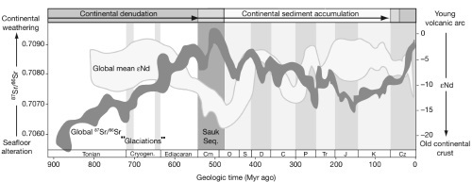Figure 1: Summary of major geochemical and sedimentary patterns derived from Upper Proterozoic to Phanerozoic strata (modified from Peters and Gaines).² Click for larger view.
The Great Unconformity can be traced across North America and globally, including most of today’s southern hemisphere landmasses, along with Western Europe and Siberia—this makes it the “most widely recognised and distinctive stratigraphic surface in the rock record”.²
This surface in most regions separates continental crystalline basement rock from overlying undeformed Cambrian marine fossil-bearing sedimentary rock. It thus records the onset of the denudation of continental crust, followed by the first major marine transgression (Sauk Sequence) and sediment accumulation on the continents (figure 1).²
The Great Unconformity is a clear case where uniformitarianism does not apply. Extensive planation surfaces are not forming today but channel erosion is occurring today.³ The very high energy erosion of the global Flood would have had the capacity to wear down Precambrian cratons to simultaneously form the Great Unconformity as a peneplaned surface over tremendous areas of the earth. Most Flood geologists point to this widespread erosional discontinuity in the geological record, known as the Great Unconformity, as indicating the Flood’s abrupt onset.⁴
The Sauk Sequence often has quartz and feldspar-rich basal sands overlying Precambrian basement across North America and North Africa.^{2,5} Similarly, basal sandstone units are widespread in the large (2 million km² surface area) Australian intracratonic sedimentary basin known as the Centralian Superbasin, which is believed to have formed at the time of the break-up of the Rodinia supercontinent.⁶
The Heavitree Quartzite is the basal sandstone unit of the Amadeus Basin, which is in turn part of the Centralian Superbasin.⁷ The Heavitree Quartzite has been described as an early Flood formation.⁸ In southern Israel the fossiliferous Cambrian sedimentary strata of the early Flood sit directly on the eroded surface of the crystalline basement of the northernmost Arabian-Nubian Shield.⁹ Evidence of sea level rise includes a universal fining upward sequence that has been observed in Cambrian and Lower Ordovician strata in locations across the USA (Sauk Sequence), Greenland, UK, Russia, Australia, Bolivia, and Ghana.¹⁰
The Great Unconformity can be traced across North America and globally, including most of today’s southern hemisphere landmasses.
A classic fining upward succession occurs in Grand Canyon Cambrian strata.¹¹ A Flood model has been proposed to explain the erosion of the Great Unconformity and subsequent deposition of the Cambrian Tapeats Sandstone, Bright Angel Shale, and Muav Limestone as floodwaters advanced in areas now known as Nevada, Arizona, and New Mexico.¹¹ Along with tremendous erosion of the exposed continental landmasses, torrential rain would likely have caused huge mass flows sweeping down into the adjacent seas. Upper Proterozoic mixtites, interpreted by secular scientists as occurring during ‘glaciations’ (figure 1), are more likely mass flow deposits formed in the early stage of Noah’s Flood due to enormous rainfall on the continents.^{12,13,14,15} Other Upper Proterozoic mixtites are found in the Appalachian Mountains, Scandinavia, Russian Platform, Siberia, Caledonian Mountains, northwest China, Brazil, central and southern Africa, and northwest, central and southern Australia.¹⁶

Geochemical signatures consistent with continental denudation
Numerous geochemical signatures indicative of continental denudation have been described from Upper Proterozoic strata.^{2,17SSS}
Strong evidence for an increase in continental erosion and weathering products to the global ocean is provided by measurements of Ca²⁺ in fluid inclusions.² Concentrations of Ca²⁺ show a precipitous increase from Upper Proterozoic strata to a peak in Cambrian strata.¹⁸ Much of this near threefold increase in Ca²⁺ has been attributed to greater chemical weathering of continental crust during the Sauk marine transgression.²
The abundance and distribution of the phyllosilicate mineral glauconite, (K,Na)(Fe³⁺,Al,Mg)₂(Si,Al)₄O₁₀(OH)₂, in Cambrian sediments likely required rapid authigenesis due to an unusually large flux of continental weathering products, particularly Fe³⁺, K+ and H₃SiO₄, during the formation of the Great Unconformity.² Trough cross-stratified deposits of glauconitic mineral-rich accumulations (glaucarenites, i.e. coarse-grained glauconitic mineral pellets) found in Cambro-Ordovician strata indicate a high energy environment. The abundance of thoroughly cross-stratified deposits also indicates that, at least on the cross-set scale, individual pellets were deposited and covered by other laminae very rapidly.¹⁹
Precipitation of carbonate sediments also reached a peak in the Phanerozoic, as recorded in the Cambrian-Lower Ordovician strata of the Sauk Sequence of North America.^{20,21,22} Petrographic textures (displasive growth of calcite crystals within the claystone matrix) and depleted δ¹³C values provide evidence of rapid direct precipitation of carbonate at the sediment-water interface.²³ Calcium carbonate precipitation does not require deep time as has been demonstrated by laboratory studies.²⁴
Calcium carbonate precipitation does not require deep time as has been demonstrated by laboratory studies.
Thus huge volumes of Cambro-Ordovician carbonate globally could have precipitated rapidly, likely within months during the year of Noah’s Flood. During the early stage of the Flood, the enormous runoff from continents may have contributed to the drawdown of carbon dioxide described for the Cryogenian,²⁵ since chemical weathering of silicate rocks is a major carbon dioxide sink.^{26,27}
⁸⁷Sr is a radiogenic daughter isotope of ⁸⁷Rb and is found in silicate rocks such as granite. The abundance of radiogenic ⁸⁷Sr relative to ‘common’ ⁸⁶Sr in a sample of sediment is related to the amount of sediment that originated from erosion of continental crust as opposed to that originating from the ocean. The observed increase in Upper Proterozoic strontium isotope ratios ⁸⁷Sr/⁸⁶Sr (figure 1) has been explained by accelerated rates of erosion during the so-called Pan-African orogeny, and high crustal erosion rates have been inferred from Cambrian ⁸⁷Sr/⁸⁶Sr values.²⁸
The subsequent decline in ⁸⁷Sr/⁸⁶Sr ratio in post-Cambrian strata indicates greater oceanic influence and a time of accumulation of sediments on the continents (figure 1) as more of the Sauk Sequence began to be deposited, reducing the direct erosive impact on landmasses.
The radiometric ‘timespan’ for the Upper Proterozoic to Cambrian increase in ⁸⁷Sr/⁸⁶Sr ratio is approximately 400 Ma (figure 1), but in the biblical framework the actual time elapsed would have been of the order of weeks to months.

Final comment
The erosional surface represented by the Great Unconformity is found on continents around the globe and is an exceptional boundary in earth history. This surface commonly separates Precambrian rocks from overlying Cambrian sedimentary strata. Continental denudation, enhanced chemical weathering, and changes in global ocean chemistry are indicated by numerous geochemical signatures associated with this boundary. The evidence is consistent with what would be expected from the effects of enormous rainfall and rising Flood waters/tsunami-like waves on the continents during the early Noahic Flood.

Rainbows, the Flood, and the Covenant
by Jonathan Sarfati

(Adapted from the author’s The Genesis Account. A theological, historical, and scientific commentary on Genesis 1–11.
After the Flood, Noah and all the Ark’s human and animal passengers disembarked. Then God made the Noahic Covenant. Then, as the historical account reads, God provided a sign for His covenant with Noah’s family and all living creatures—the rainbow:
Although the rainbow is a spectacular sight for man, the assurance we have that there will never be another global flood comes from God. He is the one who will ‘remember’ His covenant.
And God said, “This is the sign of the covenant that I make between me and you and every living creature that is with you, for all future generations: I have set my bow in the cloud, and it shall be a sign of the covenant between me and the earth. When I bring clouds over the earth and the bow is seen in the clouds, I will remember my covenant that is between me and you and every living creature of all flesh. And the waters shall never again become a flood to destroy all flesh. When the bow is in the clouds, I will see it and remember the everlasting covenant between God and every living creature of all flesh that is on the earth.” God said to Noah, “This is the sign of the covenant that I have established between me and all flesh that is on the earth.” (Genesis 9:12–17)
Coming from the sun shining through the dark clouds, the rainbow symbolized the heavenly pervading the earthly. And as it spans the horizon, it reminds man that God’s covenant is universal, as was the Flood that will never recur.¹
Rainbows are the result of well-known physics. When light enters at an angle into a substance where it travels more slowly (like a prism),² different wavelengths are bent differently.
Although the rainbow is a spectacular sight for man, the assurance we have that there will never be another global flood comes from God. He is the one who will ‘remember’ His covenant. Note that God ‘remembering’ doesn’t mean that he had previously forgotten; rather, it is an idiom meaning that the rainbow would signify that He is acting again on behalf of the Covenant beneficiaries, ensuring that no subsequent flood would become global.

Rainbows before the Flood?
The Noahic Covenant was certainly the first mention of the rainbow. But the Bible is silent on whether they had previously occurred. However, there are some considerations that suggest there would have been rainbows, which will be addressed in turn: the science of the rainbow, the natural laws that operated before and after the Flood, and God’s sovereign authority to ordain meanings to phenomena.

The science of the rainbow
Rainbows are the result of well-known physics. When light enters at an angle into a substance where it travels more slowly (like a prism),² different wavelengths are bent differently. This effect is called dispersion. Since colour depends on wavelength, we see this as a band of different colours. The shorter wavelengths (violet and blue) are bent the most, the longer wavelengths (red and orange) are bent the least.
©123rf.com/ktsdesign
The great creationist physicist Sir Isaac Newton experimented on dispersion by glass prisms. His experiments demonstrated that colour is a property of the light itself; coloured objects don’t generate colour, they absorb or reflect light that is already coloured.³
Actually, the dispersion is continuous; we see coloured bands because of the design of our colour vision.⁴ Newton designated seven colours to the rainbow by analogy with the seven notes of the musical scale: red, orange, yellow, green, blue, indigo, and violet, hence the mnemonic initialism ROYGBIV. But there are different designations and numbers of colours. For example, I don’t see ‘indigo’, but sometimes see a small band of blue-green (also called ‘aqua’, ‘cyan’ or ‘turquoise’).⁵ Actually, the difference might be with the names we give colours—one author suggests:
God mainly used natural causes in the preservation of Noah and the animals e.g. Noah had to build a wooden Ark; the cause and rise of the Flood—fountains of the great deep plus 40 days of rain; and its abatement—a wind, and continents rising and ocean basins sinking. This suggests a continuity between ‘natural laws’ before and after the Flood.
A careful reading of Newton’s work indicates that the color he called indigo, we would normally call blue; his blue is then what we would name blue-green or cyan.⁶
Also, dispersion can be produced from water drops, including rain. The drops also reflect the light, so we normally see rainbows only if we are between the sun and the raindrops. The reflection also explains why the sequence seems reversed: violet on the inside and red on the outside. Yet we can also see smaller rainbows with mist and sea spray.

Natural laws did not change
God mainly used natural causes in the preservation of Noah and the animals e.g. Noah had to build a wooden Ark; the cause and rise of the Flood—fountains of the great deep plus 40 days of rain; and its abatement—a wind, and continents rising and ocean basins sinking. This suggests a continuity between ‘natural laws’ before and after the Flood.
There is simply no evidence from the biblical text that natural laws functioned so differently that dispersion of light would not have occurred before the Flood. Rather, what the text does say suggests that there was no difference in the natural laws. Also, natural laws are our description of God’s normal, repeatable ways of upholding His creation, while miracles are His extraordinary means.⁷ So if rainbows were not produced, we would need to deduce that God was actively preventing dispersion. There is not the slightest evidence in the text for this.

Applying a new meaning to an existing phenomenon
Calvin, commenting on “I have set my bow in the cloud” (9:13), said:
From these words certain eminent theologians have been induced to deny, that there was any rainbow before the deluge: which is frivolous. For the words of Moses do not signify, that a bow was then formed which did not previously exist; but that a mark was engraven upon it, which should give a sign of the divine favor towards men. … Hence it is not for us to contend with philosophers respecting the rainbow; for although its colors are the effect of natural causes, yet they act profanely who attempt to deprive God of the right and authority which he has over his creatures.⁸
There are other examples of existing materials or practices that God decreed to be a new sign. E.g., Jesus ordained the Lord’s Supper out of bread and wine. He declared that this was now to be a memorial to His sacrifice of His body and blood.
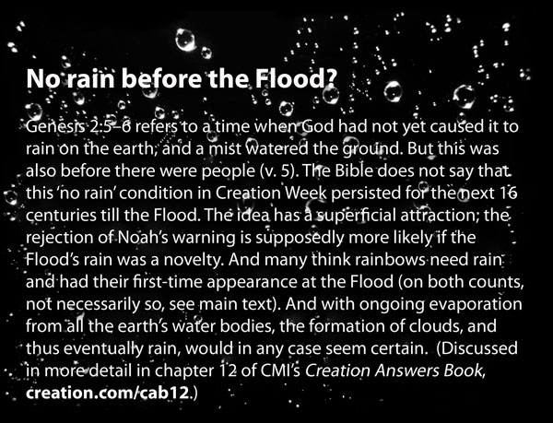

The young earth and the Flood: why they matter

Editorial
by Jonathan Sarfati
Scripture cannot be broken—Jesus (John 10:35)
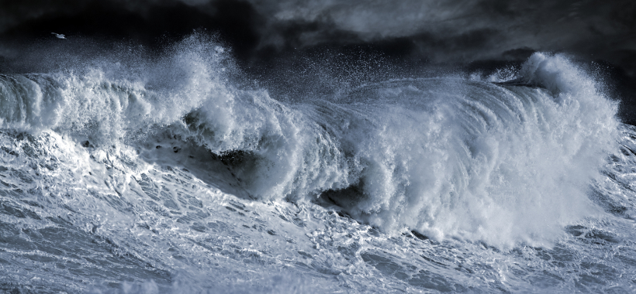
CMI is often known as a ‘young-earth creationist’ ministry. But the ‘young-earth’ issue is not our axiom, i.e. our starting assumption. Rather, it is a theorem, i.e. something logically deduced from our real axioms: the propositions (factual statements) of Scripture. How this is true, and why this matters, is shown by the two interviewees of this issue.

Pastor
All long-age ideas place rocks and fossils before Adam—and the fossils are a record of death and burial, and often disease and pain. This would entail death before Adam’s sin. But if death isn’t the result of sin, then how could Christ’s death pay for sin?
When Steve Müller (pp. 36–38) first read the Bible, the great Gospel/Resurrection chapter of 1 Corinthians 15 stood out. And this clearly links the Resurrection of “the last Adam”, Jesus, to the sin and death brought by “the first man, Adam”. It was this sin that brought death and suffering into the world God created “very good” (Genesis 1:31). But all long-age ideas place rocks and fossils before Adam—and the fossils are a record of death and burial, and often disease and pain. This would entail death before Adam’s sin. But if death isn’t the result of sin, then how could Christ’s death pay for sin?
Then other propositions of Scripture reinforced this. Ps. Müller became aware there were many passages showing that people were there “from the beginning of creation”, not billions of years after the beginning. And the genealogy of Genesis 5, which Luke 3 quotes as real history, demonstrates that God created a little over 6,000 years ago.
Ps. Müller points out that this issue is not just vital for the Gospel (see also p. 16). It also directly reinforces the authority of Scripture; with the corollary that old-earth compromise undermines Scripture. It also points to the goodness of God, who did not create a world with death and disease. Ps. Müller likes to illustrate this with exquisite pictures of dinosaurs in Eden.

Geologist
In physical processes, intensity can often be traded for time. Since the Flood was so intense, it explains most of the rocks and fossils on earth, without the need for millions of years.
If the fossils came after Adam’s sin, what could have produced them? Geologist Phil Worts (pp. 20–23) realized the answer: the Flood of Noah’s day. Genesis has three whole chapters on this, and Jesus affirmed the reality of the Flood, Ark, and Noah (Luke 17:26–27).
However, this went against all the secular teaching Phil Worts had experienced. Yet he s found that a global Flood made so much sense of the real evidence. For instance, he found beautifully preserved fossil jellyfish. This was a real problem for long-age evolutionary beliefs, because they were ‘dated’ 2 billion years before any complex life was meant to have evolved. Also, how could something as soft as a jellyfish be preserved at all? This points to rapid burial so it had no chance to disintegrate.
This ties to the age issue, because in physical processes, intensity can often be traded for time. Since the Flood was so intense, it explains most of the rocks and fossils on earth, without the need for millions of years. In turn, without millions of years, evolution is impossible.

More evidence for young earth and global Flood
Of course, this issue has still more evidence for the young earth, e.g. soft tissue from Triceratops bone (p. 53), the non-evolution of coelacanths (pp. 39–41), and fast gems (pp. 54–55). And the genuine biblical global Flood explains the attractive formation called the Eye of the Sahara (pp. 12–16). We also caution against counterfeit biblical flood claims, such as Sir Leonard Woolley’s silt layer (p. 52).

God glorified in creation
Even though the creation has been marred by sin, and the earth was totally covered by a Flood, the wonders of creation are still very plain (Romans 1:20). For example, the earth itself is amazingly well designed for life (pp. 32–35). Many creatures on it exhibit exquisite design, such as the great pterosaurs (pp. 24–27), bats that can ‘see’ magnetism (p. 48–49), and beetles with super-strong exoskeletons (pp. 50–51).
And even though we humans descend from fallen Adam, we are still God’s image-bearers who exercise dominion (pp. 46–47). No wonder that all babies are programmed with language ability (pp. 42–43), and that humans have always been ingenious from ancient times (pp. 17–19).

Can Flood geology explain thick chalk beds?
by Andrew A. Snelling
Most people would have heard of, or seen (whether in person or in photographs), the famous White Cliffs of Dover in southern England. The same beds of chalk are also found along the coast of France on the other side of the English Channel. The chalk beds extend inland across England and northern France, being found as far north and west as the Antrim Coast and adjoining areas of Northern Ireland. Extensive chalk beds are also found in North America, through Alabama, Mississippi and Tennessee (the Selma Chalk), in Nebraska and adjoining states (the Niobrara Chalk), and in Kansas (the Fort Hayes Chalk).¹
The Latin word for chalk is creta. Those familiar with the geological column and its evolutionary time-scale will recognize this as the name for one of its periods—the Cretaceous. Because most geologists believe in the geological evolution of the earth’s strata and features over millions of years, they have linked all these scattered chalk beds across the world into this so-called ‘chalk age’, that is, a supposedly great period of millions of years of chalk bed formation.

So What Is Chalk?
Porous, relatively soft, fine-textured and somewhat friable, chalk normally is white and consists almost wholly of calcium carbonate as the common mineral calcite. It is thus a type of limestone, and a very pure one at that. The calcium carbonate content of French chalk varies between 90 and 98%, and the Kansas chalk is 88–98% calcium carbonate (average 94%).² Under the microscope, chalk consists of the tiny shells (called tests) of countless billions of microorganisms composed of clear calcite set in a structureless matrix of fine-grained calcium carbonate (microcrystalline calcite). The two major microorganisms whose remains are thus fossilised in chalk are foraminifera and the spikes and cells of calcareous algæ known as coccoliths and rhabdoliths.
How then does chalk form? Most geologists believe that ‘the present is the key to the past’ and so look to see where such microorganisms live today, and how and where their remains accumulate. The foraminifera found fossilised in chalk are of a type called the planktonic foraminifera, because they live floating in the upper 100–200 metres of the open seas. The brown algæ that produce tiny washer-shaped coccoliths are known as coccolithophores, and these also float in the upper section of the open seas.
The oceans today cover almost 71% of the earth’s surface. About 20% of the oceans lie over the shallower continental margins, while the rest covers the deeper ocean floor, which is blanketed by a variety of sediments. Amongst these are what are known as oozes, so-called because more than 30% of the sediment consists of the shells of microorganisms such as foraminifera and coccolithophores.³ Indeed, about half of the deep ocean floor is covered by light-coloured calcareous (calcium carbonate-rich) ooze generally down to depths of 4,500–5,000 metres. Below these depths the calcium carbonate shells are dissolved. Even so, this still means that about one quarter of the surface of the earth is covered by these shell — rich deposits produced by these microscopic plants and animals living near the surface of the ocean.
Geologists believe that these oozes form as a result of these microorganisms dying, with the calcium carbonate shells and coccoliths falling slowly down to accumulate on the ocean floor. It has been estimated that a large 150 micron (0.15mm or 0.006 inch) wide shell of a foraminifer may take as long as 10 days to sink to the bottom of the ocean, whereas smaller ones would probably take much longer. At the same time, many such shells may dissolve before they even reach the ocean floor. Nevertheless, it is via this slow accumulation of calcareous ooze on the deep ocean floor that geologists believe chalk beds originally formed.

The ‘Problems’ For Flood Geology
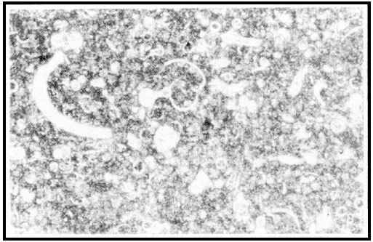Microfossils and microcrystalline calcite—Cretaceous chalk, Ballintoy Harbour, Antrim Coast, Northern Ireland under the microscope (60x) (photo: Dr. Andrew Snelling)
This is the point where critics, and not only those in the evolutionist camp, have said that it is just not possible to explain the formation of the chalk beds in the White Cliffs of Dover via the geological action of the Flood (Flood geology). The deep-sea sediments on the ocean floor today average a thickness of about 450 metres (almost 1,500 feet), but this can vary from ocean to ocean and also depends on proximity to land.⁴ The sediment covering the Pacific Ocean Basin ranges from 300 to 600 metres thick, and that in the Atlantic is about 1,000 metres thick. In the mid-Pacific the sediment cover may be less than 100 metres thick. These differences in thicknesses of course reflect differences in accumulation rates, owing to variations in the sediments brought in by rivers and airborne dust, and the production of organic debris within the ocean surface waters. The latter is in turn affected by factors such as productivity rates for the microorganisms in question, the nutrient supply and the ocean water concentrations of calcium carbonate. Nevertheless, it is on the deep ocean floor, well away from land, that the purest calcareous ooze has accumulated which would be regarded as the present-day forerunner to a chalk bed, and reported accumulation rates there range from 1–8cm per 1,000 years for calcareous ooze dominated by foraminifera and 2–10 cm per 1,000 years for oozes dominated by coccoliths.⁵
Now the chalk beds of southern England are estimated to be around 405 metres (about 1,329 feet) thick and are said to span the complete duration of the so-called Late Cretaceous geological period,⁶ estimated by evolutionists to account for between 30 and 35 million years of evolutionary time. A simple calculation reveals that the average rate of chalk accumulation therefore over this time period is between 1.16 and 1.35cm per l,000 years, right at the lower end of today’s accumulation rates quoted above. Thus the evolutionary geologists feel vindicated, and the critics insist that there is too much chalk to have been originally deposited as calcareous ooze by the Flood.
But that is not the only challenge creationists face concerning deposition of chalk beds during the Flood. Schadewald has insisted that if all of the fossilised animals, including the foraminifera and coccolithophores whose remains are found in chalk, could be resurrected, then they would cover the entire planet to a depth of at least 45cm (18 inches), and what could they all possibly have eaten?⁷ He states that the laws of thermodynamics prohibit the earth from supporting that much animal biomass, and with so many animals trying to get their energy from the sun the available solar energy would not nearly be sufficient. Long-age creationist Hayward agrees with all these problems.⁸
Even creationist Glenn Morton has posed similar problems, suggesting that even though the Austin Chalk upon which the city of Dallas (Texas) is built is little more than several hundred feet (upwards of 100 metres) of dead microscopic animals, when all the other chalk beds around the world are also taken into account, the number of microorganisms involved could not possibly have all lived on the earth at the same time to thus be buried during the Flood.⁹ Furthermore, he insists that even apart from the organic problem, there is the quantity of carbon dioxide (CO₂ ) necessary to have enabled the production of all the calcium carbonate by the microorganisms whose calcareous remains are now entombed in the chalk beds. Considering all the other limestones too, he says, there just couldn’t have been enough CO₂ in the atmosphere at the time of the Flood to account for all these calcium carbonate deposits.

Creationist Responses
Two creationists have done much to provide a satisfactory response to these objections against Flood geology—geologists Dr Ariel Roth of the Geoscience Research Institute (Loma Linda, California) and John Woodmorappe. Both agree that biological productivity does not appear to be the limiting factor. Roth¹⁰ suggests that in the surface layers of the ocean these carbonate-secreting organisms at optimum production rates could produce all the calcareous ooze on the ocean floor today in probably less than 1,000 or 2,000 years. He argues that, if a high concentration of foraminifera of 100 per litre of ocean water were assumed,¹¹ a doubling time of 3.65 days, and an average of 10,000 foraminifera per gram of carbonate,¹² the top 200 metres of the ocean would produce 20 grams of calcium carbonate per square centimetre per year, or at an average sediment density of 2 grams per cubic centimetre, 100 metres in 1,000 years. Some of this calcium carbonate would be dissolved at depth so the time factor would probably need to be increased to compensate for this, but if there was increased carbonate input to the ocean waters from other sources then this would cancel out. Also, reproduction of foraminifera below the top 200 metres of ocean water would likewise tend to shorten the time required.
Coccolithophores on the other hand reproduce faster than foraminifera and are amongst the fastest growing planktonic algæ,¹³ sometimes multiplying at the rate of 2.25 divisions per day. Roth suggests that if we assume an average coccolith has a volume of 22 x 10⁻¹² cubic centimetres, an average weight of 60 x 10⁻¹² grams per coccolith,¹⁴ 20 coccoliths produced per coccolithophore, 13 x 10⁶ coccolithophores per litre of ocean water,¹⁵ a dividing rate of two times per day and a density of 2 grams per cubic centimetre for the sediments produced, one gets a potential production rate of 54cm (over 21 inches) of calcium carbonate per year from the top 100 metres (305 feet) of the ocean. At this rate it is possible to produce an average 100 metre (305 feet) thickness of coccoliths as calcareous ooze on the ocean floor in less than 200 years. Again, other factors could be brought into the calculations to either lengthen or shorten the time, including dissolving of the carbonate, light reduction due to the heavy concentration of these microorganisms, and reproducing coccoliths below the top 100 metres of ocean surface, but the net result again is to essentially affirm the rate just calculated.
Woodmorappe¹⁶ approached the matter in a different way. Assuming that all limestones in the Upper Cretaceous and Tertiary divisions of the geological column are all chalks, he found that these accounted for 17.5 million cubic kilometres of rock. (Of course, not all these limestones are chalks, but he used this figure to make the ‘problem’ more difficult, so as to get the most conservative calculation results.) Then using Roth’s calculation of a 100 metre thickness of coccoliths produced every 200 years, Woodmorappe found that one would only need 21.1 million square kilometres or 4.1% of the earth ’s surface to be coccolith-producing seas to supply the 17.5 million cubic kilometres of coccoliths in 1,600-1,700 years, that is, in the pre-Flood era. He also made further calculations by starting again from the basic parameters required, and found that he could reduce that figure to only 12.5 million square kilometres of ocean area or 2.5% of the earth’s surface to produce the necessary exaggerated estimate of 17.5 million cubic kilometres of coccoliths.

‘Blooms’ During The Flood
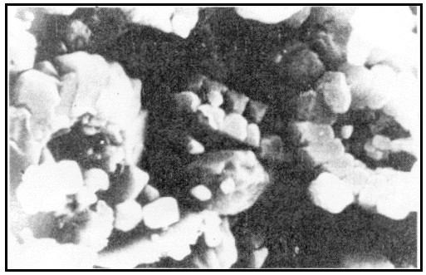Scanning electron microscope (SEM) image of coccoliths in the Cretaceous chalk, Brighton, England (photo: Dr Joachim Scheven)
As helpful as they are, these calculations overlook one major relevant issue — these chalk beds were deposited during the Flood. Creationist geologists may have different views as to where the pre-Flood/Flood boundary is in the geological record, but the majority would regard these Upper Cretaceous chalks as having been deposited very late in the Flood. That being the case, the coccoliths and foraminiferal shells that are now in the chalk beds would have to have been produced during the Flood itself, not in the 1,600–1,700 years of the pre-Flood era as calculated by Woodmorappe, for surely if there were that many around at the outset of the Flood these chalk beds should have been deposited sooner rather than later during the Flood event. Similarly, Roth’s calculations of the required quantities potentially being produced in up to 1,000 years may well show that the quantities of calcareous oozes on today’s ocean floors are easily producible in the time-span since the Flood, but these calculations are insufficient to show how these chalk beds could be produced during the Flood itself.
Nevertheless, both Woodmorappe and Roth recognize that even today coccolith accumulation is not steady-state but highly episodic, for under the right conditions significant increases in the concentrations of these marine microorganisms can occur, as in plankton ‘blooms’ and red tides. For example, there are intense blooms of coccoliths that cause ‘white water’ situations because of the coccolith concentrations,¹⁷ and during bloom periods in the waters near Jamaica microorganism numbers have been reported as increasing from 100,000 per litre to 10 million per litre of ocean water.¹⁸ The reasons for these blooms are poorly understood, but suggestions include turbulence of the sea, wind,¹⁹ decaying fish,²⁰ nutrients from freshwater inflow and upwelling, and temperature.²¹
Without a doubt, all of these stated conditions would have been generated during the catastrophic global upheaval of the Flood, and thus rapid production of carbonate skeletons by foraminifera and coccolithophores would be possible. Thermodynamic considerations would definitely not prevent a much larger biomass such as this being produced, since Schadewald who raised this as a ‘problem’ is clearly wrong. It has been reported that oceanic productivity 5–10 times greater than the present could be supported by the available sunlight, and it is nutrient availability (especially nitrogen) that is the limiting factor.²² Furthermore, present levels of solar ultraviolet radiation inhibit marine planktonic productivity.²³
Quite clearly, under cataclysmic Flood conditions, including torrential rain, sea turbulence, decaying fish and other organic matter, and the violent volcanic eruptions associated with the ‘fountains of the deep’, explosive blooms on a large and repetitive scale in the oceans are realistically conceivable, so that the production of the necessary quantities of calcareous ooze to produce the chalk beds in the geological record in a short space of time at the close of the Flood is also realistically conceivable. Violent volcanic eruptions would have produced copious quantities of dust and steam, and the possible different mix of gases than in the present atmosphere could have reduced ultraviolet radiation levels. However, in the closing stages of the Flood the clearing and settling of this debris would have allowed increasing levels of sunlight to penetrate to the oceans.
Ocean water temperatures would have been higher at the close of the Flood because of the heat released during the cataclysm, for example, from volcanic and magmatic activity, and the latent heat from condensation of water. Such higher temperatures have been verified by evolutionists from their own studies of these rocks and deep-sea sediments,²⁴ and would have also been conducive to these explosive blooms of foraminifera and coccolithophores. Furthermore, the same volcanic activity would have potentially released copious quantities of nutrients into the ocean waters, as well as prodigious amounts of the CO₂ that is so necessary for the production of the calcium carbonate by these microorganisms. Even today the volcanic output of CO₂ has been estimated at about 6.6 million tonnes per year, while calculations based on past eruptions and the most recent volcanic deposits in the rock record suggest as much as a staggering 44 billion tonnes of CO₂ have been added to the atmosphere and oceans in the recent past (that is, in the most recent part of the post-Flood era).²⁵

The Final Answer
The situation has been known where pollution in coastal areas has contributed to the explosive multiplication of microorganisms in the ocean waters to peak concentrations of more than 10 billion per litre.²⁶ Woodmorappe has calculated that in chalk there could be as many as 3 x 10¹³ coccoliths per cubic metre if densely packed (which usually isn’t the case), yet in the known bloom just mentioned, 10 billion microorganisms per litre of ocean water equates to 10¹³ microorganisms per cubic metre.
Adapting some of Woodmorappe’s calculations, if the 10% of the earth’s surface that now contains chalk beds was covered in water, as it still was near the end of the Flood, and if that water explosively bloomed with coccolithophores and foraminifera with up to 10¹³ microorganisms per cubic metre of water down to a depth of less than 500 metres from the surface, then it would have only taken two or three such blooms to produce the required quantity of microorganisms to be fossilised in the chalk beds. Lest it be argued that a concentration of 10¹³ microorganisms per cubic metre would extinguish all light within a few metres of the surface, it should be noted that phytoflagellates such as these are able to feed on bacteria, that is, planktonic species are capable of heterotrophism (they are ‘mixotrophic’).²⁷ Such bacteria would have been in abundance, breaking down the masses of floating and submerged organic debris (dead fish, plants, animals, etc.) generated by the flood. Thus production of coccolithophores and foraminifera is not dependent on sunlight, the supply of organic material potentially supporting a dense concentration.
Since, for example, in southern England there are three main chalk beds stacked on top of one another, then this scenario of three successive, explosive, massive blooms coincides with the rock record. Given that the turnover rate for coccoliths is up to two days,²⁸ then these chalk beds could thus have been produced in as little as six days, totally conceivable within the time framework of the flood. What is certain, is that the right set of conditions necessary for such blooms to occur had to have coincided in full measure to have explosively generated such enormous blooms, but the evidence that it did happen is there for all to plainly see in these chalk beds in the geological record. Indeed, the purity of these thick chalk beds worldwide also testifies to their catastrophic deposition from enormous explosively generated blooms, since during protracted deposition over supposed millions of years it is straining credulity to expect that such purity would be maintained without contaminating events depositing other types of sediments. There are variations in consistency (see Appendix) but not purity. The only additional material in the chalk is fossils of macroscopic organisms such as ammonites and other molluscs, whose fossilisation also requires rapid burial because of their size (see Appendix).
No doubt there are factors that need to be better quantified in such a series of calculations, but we are dealing with a cataclysmic Flood, the like of which has not been experienced since for us to study its processes. However, we do have the results of its passing in the rock record to study, and it is clear that by working from what is known to occur today, even if rare and catastrophic by today’s standards, we can realistically calculate production of these chalk beds within the time framework and cataclysmic activity of the Flood, and in so doing respond adequately to the objections and ‘problems’ raised by the critics.

Appendix: ‘Hardgrounds’ and Other Fossils
The English chalk beds consist of alternating thin hard layers and thicker soft layers. The thin hard layers (or ‘Hardgrounds’) are encrusted on their upper surfaces with mollusc shells, worm tubes and bryozoan (lace coral) skeletons and show the work of various boring organisms. Consequently, Wonderly insists that:
‘it is thus obvious that during the formation of the chalk beds each hard layer was exposed to the sea water long enough to be bored by organisms and then encrusted by the animals which attached themselves. … This is of course also a record of the passage of many thousands of years’.¹
Wonderly thus sees this as evidence that Noah’s Flood could not have deposited these chalk beds, and that the rock record took millions of years to form.
Scheven² is equally familiar with ‘hardgrounds’ in his experience in the German Muschelkalk of the so-called Middle Triassic. In his Flood geology model, Scheven places these strata, and the English chalk beds, into the immediate post-Flood era, but in no way does he see any evidence in these rocks for the thousands of years that are so ‘obvious’ to Wonderly. Indeed, Scheven agrees that the chalk accumulated via mass propagations amidst mass extinctions and catastrophe. Furthermore, he describes the banding now observable in these chalk beds as due to transport and redeposition of calcareous ooze by water.
But what of the borings and encrusted shells and tubes? These are not necessarily the conclusive ‘proof’ of thousands of years Wonderly insists they are. Molluscs, worms and other marine life were left outside the Ark, some to survive the Flood, in their marine ‘home’. Once the explosive blooms had generated the voluminous foraminiferal shells and coccoliths, these would then sink and be swept away by the Flood currents before being deposited in the alternating bands of the chalk beds. Other marine life would have been trapped by these surges and entombed alive, hence their presence in the chalk beds. In whatever moments they had before expiring, it is not inconceivable that some of these creatures would try to reestablish their living positions on whatever momentary surfaces they found themselves on.

- Ed. Note: See also Dr Tas Walker’s answer to a critic, Are hardgrounds really a challenge to the global Flood?
- The Genesis Flood and Noah’s Ark
- Fact or fiction?
- by Tas Walker
- Many doubt the biblical story of Noah’s Flood. To many the story seems a gross exaggeration or a work of fiction. And if Noah’s Flood is not believable, why trust any historical account in the Bible? People have posed many objections to a factual interpretation of this event and this article (and the articles linked to it) answers many of the key questions people have about the Flood and the Ark.

Contents
1. Was the Ark big enough?
• Could Noah have built an Ark that big?
• How could all the animals fit?
• How could Noah collect all the animals?
• Were dinosaurs on board?
• Weren’t dinosaurs extinct long before the Flood?
2. Was the Flood really global?
• The Bible describes a global Flood
• Where did the water come from?
• How could the Ark survive the Flood?
• How could Noah look after all those animals?
• Did the Flood destroy everything alive?
• Where did the water go?
3. Is there historical evidence of the Flood?
• What about geological evidence?
• How could fossils millions of years old form in the Flood?
• How could animals migrate from Mount Ararat all over the earth?
• Has Noah’s Ark been found?
• Why did God destroy the earth?
4. Does Noah’s Ark have a message for us?
• Here’s the good news
- 1. Was the Ark big enough?
- Many people imagine the Ark like an overgrown floating bathtub, with giraffes, elephants and Noah standing on the deck waving to whales splashing in the water. However, the Bible describes an enormous vessel.
- The length of the Ark shall be three hundred cubits, its width fifty cubits, and its height thirty cubits. (Genesis 6:15)
- Wikipedia.org/VcxSemi-trailer
- That is 140 m long, 23 m wide and 14 m high.¹ It was longer than a football field and higher than a four-storey building. It had three decks and a volume of about 44,400 m³ (1.52 million cu ft).
- This is the equivalent volume of over 340 US ‘semi-trailers’ (a semi-trailer is 40 ft long and 8.5 ft wide, and about 13 ft high [4,420 cu. ft]. Note that the Ark would be wider than a six-lane US Interstate highway (standard lane width 12 ft). A semi-trailer can haul 37 1,200-pound slaughter steers, 90 500-pound feeder calves, 180 250-pound hogs, or 300 125-pound sheep.²
- The Ark reminds us that, even in judgment, the Creator God provides a way of escape for those who believe and obey Him.
- Could Noah have built an Ark that big?
- People in Noah’s time had no less physical strength or mental ingenuity than people today. By saying that ancient people were more primitive we are expressing an evolutionary idea.
- In Genesis 4 we see that Adam’s descendants were cultivating crops, farming animals, playing musical instruments, building cities, and forging bronze and iron. The engineering techniques, tools and machines of ancient man were much more ingenious than is often realized.
- Not long after the Flood, the Egyptians, for example, were writing, cutting granite and precision-building great pyramids.
- The first man that God created was perfect. In the 6,000 years since then, our intellect has most likely deteriorated due to the effects of the curse. Fortunately, we have more than counteracted for any such loss of ability by storing and passing on information and discoveries.
- 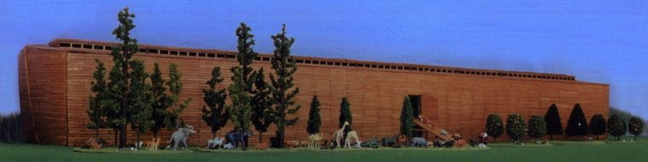The vast size of the Ark.
- We are not told that Noah and his sons did all the work on their own, even though that would have been possible for them. It is likely that they paid other people to harvest and transport the timber, cut the planks and handle the huge beams used to frame the vessel.
- In Genesis 4 we see that Adam’s descendants were cultivating crops, farming animals, playing musical instruments, building cities, and forging bronze and iron.
- Classical literature records huge wooden ships of a comparable size to the Ark.³ The catamaran galley of Tessarakonteres, built for Ptolemy IV in 210 BC, was 128 m long—almost as big as the Ark. It was powered with three banks of oarsmen and carried up to four thousand soldiers. The Leontifera from Heraclea, maybe 120–150 m (400–500 ft) long, which performed admirably in an Aegean Sea battle in 280 BC. Much later, Chinese admiral Zheng He (or Cheng Ho, 1371–1433) made long ocean voyages with a fleet that included gigantic nine-masted treasure ships about 130 m long and 50 m wide.⁴ If wooden ships of comparable size were built and functioned well, then obviously functioning wooden ships that size could be built.
- And Noah’s Ark was far simpler than the racing hull of a Greek warship. Think of the Ark as an ocean-going barge, with a strong hull to handle the waves.
- How could all the animals fit?
- To start, God did not tell Noah to take every kind of animal on board. It was only the air-breathing, land-dwelling animals that would have perished in the Flood.⁵
- Whales, fish and other aquatic creatures like clams and shrimps would survive in the water outside the Ark. So would most amphibians and insects. This greatly reduced the number of animals needed on board.
- Also, the biblical kind was much broader than today’s species. Related species that populated the earth today would have descended quite rapidly from just one parent ‘kind’ on board the Ark. This was understood by pre-Darwinian creationists. The Bible says:
- The amazing variety in all the animals we have today has been bred from just a few ‘mongrels’ of each sort of animal that was on board Noah’s Ark.
- And of every living thing of all flesh, you shall bring two of every sort into the Ark to keep them alive with you. They shall be male and female. (Genesis 6:19)
- For example, today we have more than 200 types of ‘dogs’ including coyotes, foxes, jackals and wolves. These, together with our domestic dogs (from the Great Dane to the Toy Poodle) are all likely descended from one original ‘dog kind’.
- It is the same with the other animals, like the cat kind, horse kind and cow kind. The amazing variety in all the animals we have today has been bred from just a few ‘mongrels’ of each sort of animal that was on board Noah’s Ark.
- iStockphoto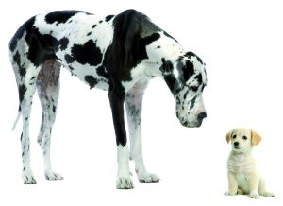All today’s species of dogs are likely descended from one original ‘dog kind’
- John Woodmorappe, in his book Noah’s Ark: A Feasibility Study, estimates that 16,000 animals, at the very most, needed to be housed on the Ark. This was treating the kind as equivalent to the modern man-made category of ‘genus’. If the kind were as broad as a family, then only about 2,000 animals would have been needed.
- How could Noah collect all the animals?
- Noah didn’t have to travel to far-away places and collect all the animals to bring them on board. The Bible tells us that God sent the animals to Noah without being rounded up:
- Of birds after their kind, of animals after their kind, and of every creeping thing of the earth after its kind, two of every kind will come to you to keep them alive.(Genesis 6:20)
- This would have been a supernatural gathering, but we see amazing animal behaviours in the world today (worldwide migrations [Monarch butterflies, albatross, salmon, whales etc.] and other activities such as hibernation and awareness of earthquakes).
- Like other creatures, the number of dinosaur kinds would have been much less than the number of genera assigned to them.
- Plus the arrangement of the continents and the climate was different before the Flood. Noah likely lived in a region that was able to support all the biblical kinds without them needing to travel very far. More variation within the kinds would have developed in the animal kinds after the Flood, due to greater variation in environments and ecological niches. Also, the best conditions for rapid variation and speciation occur with small, geographically isolated populations—just like those dispersing from the mountains of Ararat!
- Were dinosaurs on board?
- Yes. Dinosaurs were just another air-breathing land-dwelling animal that God made along with the others. This is clear from the fact that dinosaur fossils were clearly buried in the Flood, showing that dinosaurs were alive with Noah. Thus they would logically have been included in the land animals taken as passengers. But how would they fit?
- Some dinosaurs were smaller than chickens (with no relation to birds; God created dinosaurs a day after He created birds). The average adult size of all kinds of dinosaurs was about the size of a buffalo.
- 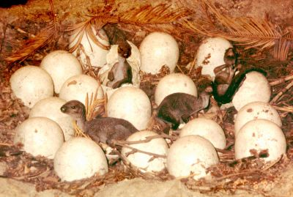Reconstruction of a ‘nest’ of dinosaur eggs.
- Dinosaurs hatch out of eggs, and the largest egg is only about football size. Indeed, they could not be much larger, otherwise the shell thickness needed to support the weight would block oxygen flow to the embryo. Also, analysing growth rings on dinosaur bones show that they went through a juvenile growth spurt. It would make sense for God to choose pre-growth-spurt dinos. So, even the biggest dinosaurs, like Apatosaurus and Brachiosaurus, would easily fit on the Ark when young. Elephants and rhinos could have been handled the same way. Flying reptiles, such as the pterodactyl, were on the Ark too, but not marine reptiles such as the plesiosaur.
- Like other creatures, the number of dinosaur kinds would have been much less than the number of genera assigned to them. Also, paleontologists have recently recognized that baby and subadult specimens have been given different names to the adult specimens of the same type of dinosaur.
- Weren’t dinosaurs extinct long before the Flood?
- No. The belief that dinosaurs died out long before man is an evolutionary idea. In Genesis we see that God made all the land-dwelling creatures on Day Six of creation week about 6,000 years ago. That included dinosaurs, since they were land animals. He made Adam and Eve on the same day.
- There is strong scientific evidence that the dinosaurs were not millions of years old. Scientists have found soft tissue, proteins, and DNA in dino bones, but this should have all disintegrated in a fraction of the time.
- In Job chapter 40 (after the Flood) the description of behemoth with a tail like a cedar, the biggest tree of the middle east only matches an animal like a sauropod dinosaur. So behemoth’s ancestors must have been on board the Ark, therefore dinosaurs were alive after the Flood.
- 2. Was the Flood really global?
- Evolution (or even just ‘millions of years’) also means that the fossils, which represent pain, death, bloodshed, disease and suffering, formed before Adam and Eve sinned.
- Many say Noah’s Flood (if a real event) was only a local flood. Why? Because they believe our world is millions of years old. In that view, the fossils in the rock layers represent the appearance of new forms of life over eons of time.
- But scientists did not always see the fossils that way. Geological pioneers, like Nicholas Steno, connected the fossils, buried in water deposits of mud and sand, with Noah’s Flood.
- Ideas (like families) are related. The idea of evolution means the ‘fossil record’ accumulated gradually over millions of years, and that means there is no geological evidence for Noah’s Flood. So, Christians who believe in evolution and/or millions of ‘geological years’ must insist on a local flood.
- Evolution (or even just ‘millions of years’) also means that the fossils, which represent pain, death, bloodshed, disease and suffering, formed before Adam and Eve sinned. So, what did God mean when He described His finished creation as ‘very good’? Evolution means that death and suffering are not the result of sin. That destroys the meaning of the death and resurrection of Christ.
- The Bible describes a global Flood
- Wikipedia.org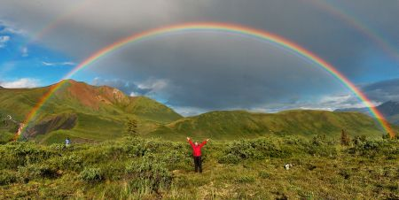God’s rainbow promise means the Flood was global.
- If the Flood was just a local affair why was the Ark so huge? They could have walked out of the area and been safe! Why put birds on board? They could have flown away. Jesus believed that, apart from Noah and his family, the Flood killed everyone (Matthew 24:37–39). If the Flood were local, people who lived outside the area would not have been affected. They would have escaped God’s judgment on sin.
- Also, Christ compared the coming world judgment to the judgment of ‘all’ men in the days of Noah (Matthew 24:37–39). So did Peter (2 Peter 3). A local Flood in Noah’s day would mean the judgment to come would not affect everyone.
- How could the waters rise above the mountains (Genesis 7:20) and the Flood be just local? Water seeks its own level.
- God used the rainbow in the sky as a sign that He would never destroy the earth with water again. But there have been many terrible ‘local’ floods (the Lake Missoula flood or more recently in New Orleans, for example)—but never a global Flood that destroyed all land creatures. If the Flood were local, God has broken His solemn promise over and over. The biblical Flood covered the whole world.
- The Bible describes two sources for the water—rain from the sky and water surging from the breaking up of ‘all the fountains’ of the ‘great deep’.
- Where did the water come from?
- iStockphoto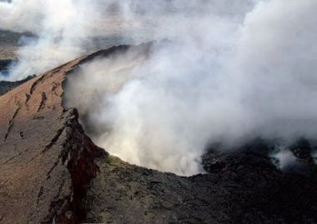Volcanic eruptions on a grand scale would have accompanied the breaking up of the great deep.
- [O]n that day all the fountains of the great deep were broken up, and the windows of heaven were opened. And the rain was on the earth forty days and forty nights. (Genesis 7:11–12)
- The Bible describes two sources for the water—rain from the sky and water surging from the breaking up of ‘all the fountains’ of the ‘great deep’. These fountains, being mentioned first, may have been the most important source of the water for the Flood. It may refer to huge underground sources of water. The ‘breaking up’ implies large-scale volcanic and earthquake activity.
- Geologists have discovered that the rocks in the mantle deep inside the earth still contain abundant (enough to fill the oceans twenty times over) water. They believe that, in the past, some of the water in the mantle came out on the earth. The mountains and land masses were different before the Flood. Some creationist scientists believe the break-up of a single continent was part of the mechanism that caused the Flood.
- How could the Ark survive the Flood?
- A study by naval architects found that the Ark specified in the Bible is one of the most stable shapes to handle large waves in a rough ocean. It would remain upright under the most adverse conditions.
- 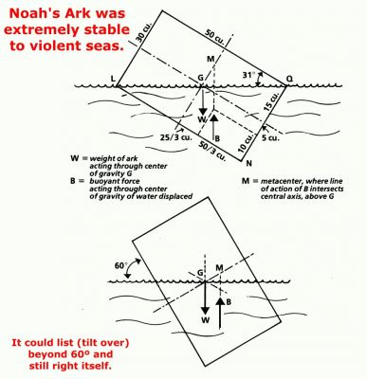Engineering analysis shows the Ark’s design was remarkably stable.
- Unlike the sailing ships of the Middle Ages, the Ark did not need to travel anywhere. It just needed to float. Slightly rounded ends may have improved the handling of the Ark in large waves, making it less likely to turn sideways into the waves. But the Bible is not clear, and it is possible that the Ark was a simple box, which would provide maximum storage and be structurally strong.
- Critics have said a vessel this size made from wood could not be strong enough, but this is not true. However, they were making the false assumption that the Ark was just a scaled-up 19th-century sailing ship. However, the worst danger is the mast and sails, because they increase the moment arm of the wind force, enabling large torques that would capsize the boat. They also had serious weaknesses with portholes, and the plank-on-frame construction is not robust.
- However, there are well-known alternative methods, such as a monocoque, where the outer shell also provides the main strength, or mortise-and-tenon joints, or cross-planking, like scaled-up plywood. Thus would be quite feasible to build a structure of biblical dimensions to handle the stress.
- How could Noah look after all those animals?
- And you shall take for yourself of all food that is eaten, and you shall gather it to yourself; and it shall be food for you and for them. (Genesis 6:21)
- Noah needed to keep the animals warm and clean, and stow enough food and water for 370 days. According to Woodmorappe, food for 16,000 animals would have taken only about 15% of the Ark’s total volume, and drinking water about 10%.⁶ This could be reduced by storing dried and compressed foodstuffs, and by collecting rainwater.
- Noah may have had systems to automatically supply water and food to the animals and clear away their waste.
- Woodmorappe estimates that eight people could care for 16,000 animals without any special devices. Deep bedding of sawdust, wood shavings or peat moss can last unchanged for many months, and would absorb moisture and odour. Some cages may have had sloped or slatted floors, so the manure could fall and be flushed away. Even in modern times, Dutch farmers keep animals over the winter months with low-maintenance stables called potstals and grupstals.
- Noah may have had systems to automatically supply water and food to the animals and clear away their waste. Today, a small group of farmers can raise thousands of cattle and other animals in a small space. We would probably be surprised at the imaginative devices on board the Ark to feed and care for the animals.
- How would Noah have powered these devices? Perhaps by wind or gravity or the rocking of the Ark. There are many possibilities.
- In a natural disaster most animals react in ways that allow them to survive. Many may even have hibernated while they were on the Ark.
- Did the Flood destroy everything alive?
- No one today has seen a hurricane, earthquake or rainstorm as destructive as Noah’s Flood. The worst natural disasters experienced in historical times are tiny compared with the global cataclysm that destroyed the earth in Noah’s day.
- The Bible speaks of the ‘fountains of the great deep’ being broken open. That means earthquakes and volcanoes as well as molten lava and super heated steam and water blasted from inside the earth in a furious, frenzied upheaval. It was only after 150 days into the Flood that these fountains were stopped.
- After a worldwide Flood, like the Bible describes, we would expect to find billions of dead things, buried in rock layers laid down by water, all over the earth. And that’s exactly what geologists find (billions of fossils in sedimentary rock layers worldwide).
- And all flesh died that moved on the earth: birds and cattle and beasts and every creeping thing that creeps on the earth, and every man. All in whose nostrils was the breath of the spirit of life, all that was on the dry land, died. (Genesis 7:21–22)
- In other words, every person and land vertebrate animal outside the Ark perished as the flood waters rose and rose relentlessly until there was nowhere to flee for safety. Of course, that did not include fish and other marine animals, although many of these perished in the cataclysm, too.
- In December 2004, an earthquake near Indonesia triggered a tsunami that devastated many countries around the Indian Ocean. Just one tsunami obliterated whole towns within a few minutes. After the water returned to the sea, the world was shocked at the destruction. Some 200,000 people perished. Imagine what would happen if the tsunamis just kept coming, one after the other, day after day for five months, until the highest mountains were covered.
- Where did the water go?
- Our earth is called the blue planet because it is mostly covered (70% of the earth’s surface) with water.
- If the world’s mountains were smoothed off and the ocean basins pushed up, making the surface even, then water would cover the earth to a depth of about three kilometres.
- Noah’s Flood caused big mountain-sized earth movements. We see lots of examples where mountain ranges were warped and folded while the sediment was still soft. Toward the end of the Flood, they were pushed up as the earth’s crust moved. The water is still here, we just live on the parts that were pushed up out of the water at the end of the Flood. Some reliable Bible scholars suggest Psalm 104:7–8 describes this when speaking of the mountains rising, the valleys sinking, and the waters flowing off the earth.
- 3. Is there historical evidence of the Flood?
- Wikipedia.org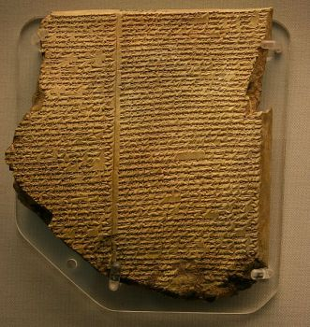The Gilgamesh Epic was recorded on clay tablets. Flood stories are found in cultures worldwide.
- Cultures all over the world retain a memory of the Flood in their local history. Several Native American tribes have global flood stories. One from the Choctaw tribe tells how, long ago, men became so corrupt that the Great Spirit destroyed them in a flood and only one man survived.
- In Hawaii, there is the legend of Nu-u who made a great canoe with a house on it and filled it with animals. The waters came up all over the earth and killed all the people and animals that weren’t on the canoe.
- Ancient Chinese writings refer to a violent catastrophe that occurred on earth and a flood that covered the highest mountains.
- The Toltec Indians of ancient Mexico have a story of a few men who escaped the destruction of a great flood that covered the highest mountains.
- The Toltec Indians of ancient Mexico have a story of a few men who escaped the destruction of a great flood that covered the highest mountains. In the story told by an aboriginal group in north-west Australia, a man with his wives and a dog battle their way to safety in a canoe, as a bird flies in front of them with a leaf in its mouth.
- One famous flood story was discovered in 1853, on tablets unearthed in ancient Nineveh. In this epic of Gilgamesh, the Babylonian Noah is called Utnapishtim. The epic has many similarities with the story of Noah’s Flood, which is why many scholars think the Genesis account was derived from it. But the Gilgamesh epic is typical of mythology, with magical beings, multiple deities, embellishment and an implausible cubical ark, whereas the Genesis account reads like real history. Both stories are probably referring to the same real event. Genesis preserves the original record, while the Gilgamesh Epic is a distorted version.
- wikipedia.org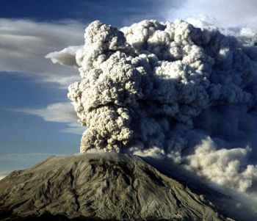Mount St Helens eruptions in the 1980s changed geological thinking.
- These stories and hundreds more have many striking similarities. This evidence supports the Bible’s account that all people are descended from the eight people who survived the global Flood. The Bible preserves a written eyewitness account of a real event in world history.
- What about geological evidence?
- When we look at the world from a biblical perspective we can see the geological evidence for the Flood everywhere. Someone said once, ‘If I hadn’t believed it I wouldn’t have seen it.’
- After a worldwide Flood, like the Bible describes, we would expect to find billions of dead things, buried in rock layers laid down by water, all over the earth. And that’s exactly what geologists find (billions of fossils in sedimentary rock layers worldwide).
- Altogether about 75% of the continental surface is sedimentary rock. Thick layers of gravel, sand and silt were laid down by water and have cemented into hard stone. Billions of plant and animal fossils are entombed inside.
- Fossils point to catastrophe and rapid burial. They could not have been buried slowly over thousands of years or they would have been eaten by scavengers or rotted away. There are lots of spectacular examples, like an ichthyosaur that was buried while giving birth. The baby ichthyosaur was fossilized too, snap frozen in time. And there are fish that were buried so quickly they did not have time to finish their meal.
- All around the world, from the deepest oceans to the highest mountains, we find evidence of Noah’s Flood. As you travel around the globe, you see how the landscapes of the earth preserve the effects of Noah’s Flood from plateaus and canyons to coal seams and cliffs. The evidence is all over the earth for everyone to see!
- How could fossils millions of years old form in the Flood?
- Many people don’t connect fossils with Noah’s Flood because the fossils are supposed to be millions of years old. But those ages are just people’s opinions; they are not measured directly. There is much evidence to indicate the world is only thousands of years old.
- 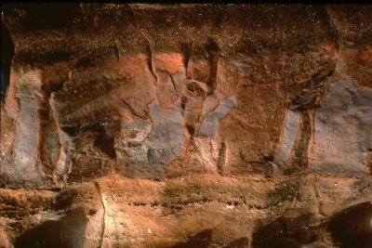Fossils buried rapidly in sediment all over the world are evidence of the Flood catastrophe. In this image they are sorted in bands.
- For example, a piece of wood was found enclosed in sandstone from a Sydney quarry. The sandstone is said to be over 200 million years old, yet when the wood was analysed for carbon-14, it indicated it was only thousands of years old. Scientists decide which date to accept depending on how it agrees with their prior beliefs about the past.
- People used to think that fine laminations in sedimentary rocks meant they accumulated slowly over thousands of years. However, when the Mount St Helens volcano exploded in June 1980, eight metres of finely layered sediment were deposited in just one hour. Geologists now realize that multiple fine layers can form quickly.
- Canyons don’t need millions of years to form, either. Although Burlingame Canyon (north west USA) looks like it eroded slowly over many thousands of years, it was cut quickly during torrential rainfall and flooding in a few days.
- Many people think rocks take millions of years to harden, but that is not correct. At a flour mill in the USA a sack of flour was petrified (turned to stone) in a few weeks when the mill was flooded by mineralized water.
- 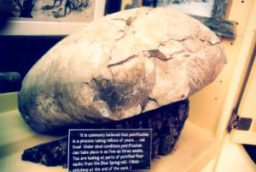Bag of flour petrified in weeks.
- At the beginning of the Industrial Revolution (1650) there were only 500 million people on earth. Population growth has been staggering. Our present world population of 7 billion people is hundreds of thousands of times too small if people have been on the earth for millions of years. Today’s population is consistent with the length of time since the Flood 4,500 years ago, not with evolution over millions of years.
- How could animals migrate from Mount Ararat all over the earth?
- Many people imagine a pair of animals leaving the Ark and heading off on an incredibly long trip. But many centuries have passed and animals would migrate over many generations.
- During the Ice Age, immediately after the Flood, sea levels were much lower, providing land bridges for animals to cross. Animals could have also travelled across the ocean on floating rafts of vegetation, something that has often been observed in recent times. Also, people could have transported many animals to different parts of the world, as they are still doing today.
- A real example can help. When cane toads were introduced, by humans, into Australia, it took only ten years for their population to spread a distance of 2,000 km. Their current rate of spread is from 5 to 50 km per year. And toads are not as mobile as other animals such as cattle, cats and many reptiles.
- After the Flood, there would have been no problem for successive population waves of animals moving into ‘empty’ ecological niches in all directions.
- Has Noah’s Ark been found?
- And the Ark rested in the seventh month, on the seventeenth day of the month, upon the mountains of Ararat. (Genesis 8:4)
- Most people associate the biblical mountain with Mount Ararat in modern-day Turkey. In spite of numerous expeditions to that mountain last century, no conclusive evidence of the Ark has been found.
- However, we can’t be sure that Mount Ararat in Turkey is the mountain that the Bible is talking about (the Bible says ‘mountains’ of Ararat not ‘mountain’). Today’s Mount Ararat has a pointed peak that would make it difficult for the Ark to land safely. Some creationists suggest the Ark rested on a mountain range in another area in the Middle East, and have proposed some regions to explore. Some suggest that modern Mount Ararat was only given that name in the past few thousand years.
- Perhaps the remains will never be found. After all, it was about 4,500 years ago that it landed, and it may have disintegrated or been demolished (perhaps for building materials or firewood). On the other hand, some Bible scholars and scientists believe the Ark could still be preserved. If it were discovered one day it would remind the world of God’s judgment in the past, and the judgment that is yet to come.
- Why did God destroy the earth?
- One of the most important lessons of Noah’s Flood is the reason why it came on the earth. The Bible says:
- And God saw that the wickedness of man was great in the earth, and that every imagination of the thoughts of his heart was only evil continually. (Genesis 6:5)
- The Flood is a warning to all people that the Creator God cares about His creation. He cares how we behave and He will judge the earth. He will also save those who trust Him.
- Everyone on the earth, except Noah, his sons and their wives, continued with their violence (Hebrew hamas, Genesis 6:11) and corruption. So God judged them. Even though the punishment was severe, all were without excuse.
- We also see that God used the Flood as His way of purifying the earth—separating those who trusted Him from those who didn’t. All through history, as we see recorded in the Bible, God has used this pattern of judgment and purification in dealing with people.
- So we need to obey God’s instructions and remember His dealings in history. Otherwise our lot will be to repeat the same mistakes and experience the same consequences, unless we heed the true history and understanding of the world as recorded in the Bible.
- 4. Does Noah’s Ark have a message for us?
- The Ark reminds us that, even in judgment, the Creator God provides a way of escape for those who believe and obey Him. And that is the message of the Bible and the good news of Jesus Christ, the way each one of us can be saved from the judgment to come.
- For the Son of man has come to save that which was lost. (Matthew 18:11)
- So, in seeking and saving the lost, the Lord Jesus Christ, God’s Son, is like an Ark of safety for us. The Ark saved Noah and his family from the flood waters. The Bible refers to a coming destruction of the earth by fire. When we trust and obey Jesus Christ as our Lord and Saviour, He will save us from all of God’s judgment to come. In order to be saved, Noah and his family had to enter the Ark through a doorway. We too need to respond to Jesus Christ, like entering a ‘doorway’. Jesus said,
- I am the door. If anyone enters by Me, he will be saved … (John 10:9)
- Here’s the good news
- Creation Ministries International seeks to give glory and honour to God as Creator, and to affirm the truth of the biblical record of the real origin and history of the world and mankind.
- Part of this real history is the bad news about the rebellion of the first man, Adam, against God’s command. His disobedience brought death, suffering and separation from God into this world. We see the results all around us.
- Though totally sinless, Jesus Christ the Creator suffered—on behalf of mankind—death and separation from God, which is the penalty of our sin.
- All of Adam’s descendants are sinful from conception (Psalm 51:5) and have themselves entered into this rebellion (sin). They therefore cannot live with a holy God, but are condemned to separation from Him. The Bible says that ‘all have sinned, and come short of the glory of God’ (Romans 3:23) and that all are therefore subject to ‘everlasting destruction from the presence of the Lord and from the glory of His power’. (2 Thessalonians 1:9)
- But the good news is that God has done something about it.
- For God so loved the world that He gave his only begotten Son, that whoever believes in Him should not perish, but have everlasting life. (John 3:16)
- Though totally sinless, Jesus Christ the Creator suffered—on behalf of mankind—death and separation from God, which is the penalty of our sin. In this way He satisfied the righteous demands of the holiness and justice of God, His Father. Jesus was the perfect sacrifice; He died on a cross, but on the third day, He rose again, conquering death, so that all who truly submit to Him, repent of their sin and trust in Him (rather than their own merit), are able to come back to God and live forever with their Creator.
- He who believes in Him is not condemned; but he who does not believe is condemned already, because he has not believed in the name of the only begotten Son of God. (John 3:18)
- What a wonderful Saviour—and what a wonderful salvation in Christ our Creator!
- If you want to know more of what the Bible says about how you can receive eternal life, please email, write or call the Creation Ministries International office nearest you—for contact details see creation.com/contact-us.

